Name:_______________________________________ Period# ____ Topic 7.2 – Weber’s Least Cost Theory
LINK: Weber’s Least Cost Theory Reading and Notes
1. Define agglomeration. Explain how agglomeration affects where industries located and give an example.

2. What is the basis for Weber’s Least Cost Theory? Draw a picture to illustrate this idea.

3. What is a weight-gaining industry? Give an example. Where will the industrial production point be located in this type of industry?

4. What is a weight-reducing industry? Give an example. Where will the industrial production point be located in this type of industry?

5. Illustrate the fictional “brick bunny” production location and explain why it is like this.

6. What are the three primary factors Weber included in his model? Which is most expensive? Which does Weber focus on most, and why?

7. What assumptions does Weber make in his theory?

8. Now put Weber’s theory to work in deciding where to locate a new brewery. Here’s the scenario:
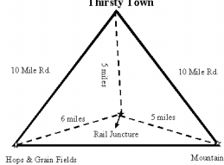
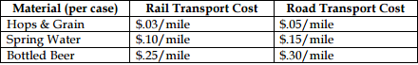
According to Weber, where will you locate the new brewery and why?

9. Now put Weber’s theory to work in deciding where to locate a new steel factory for a growing town. Here’s the scenario:
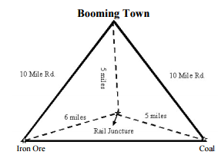
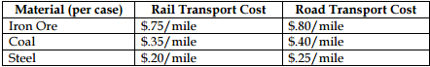
According to Weber, where will you locate the new steel factory and why?

10. These scenarios only refer only to transportation costs. They do not adequately account for variations over time. For example, when relative labor costs decline, or when land rent goes down, an industry can sustain an increase in transportation costs – this is referred to as the substitution principle. Discuss TWO other variables not mentioned by Weber that would affect the location of a factory.

