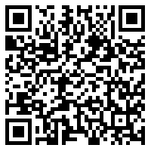
Name: _____________________________________ Period# ____

LINK: https://tinyurl.com/n8enhyy

Major Religious Regions of the United States

Directions: Use page 197 in the green textbook to color code the map AND create a key
*(HINT: You DO NOT need to use the same colors as the map in the textbook)*

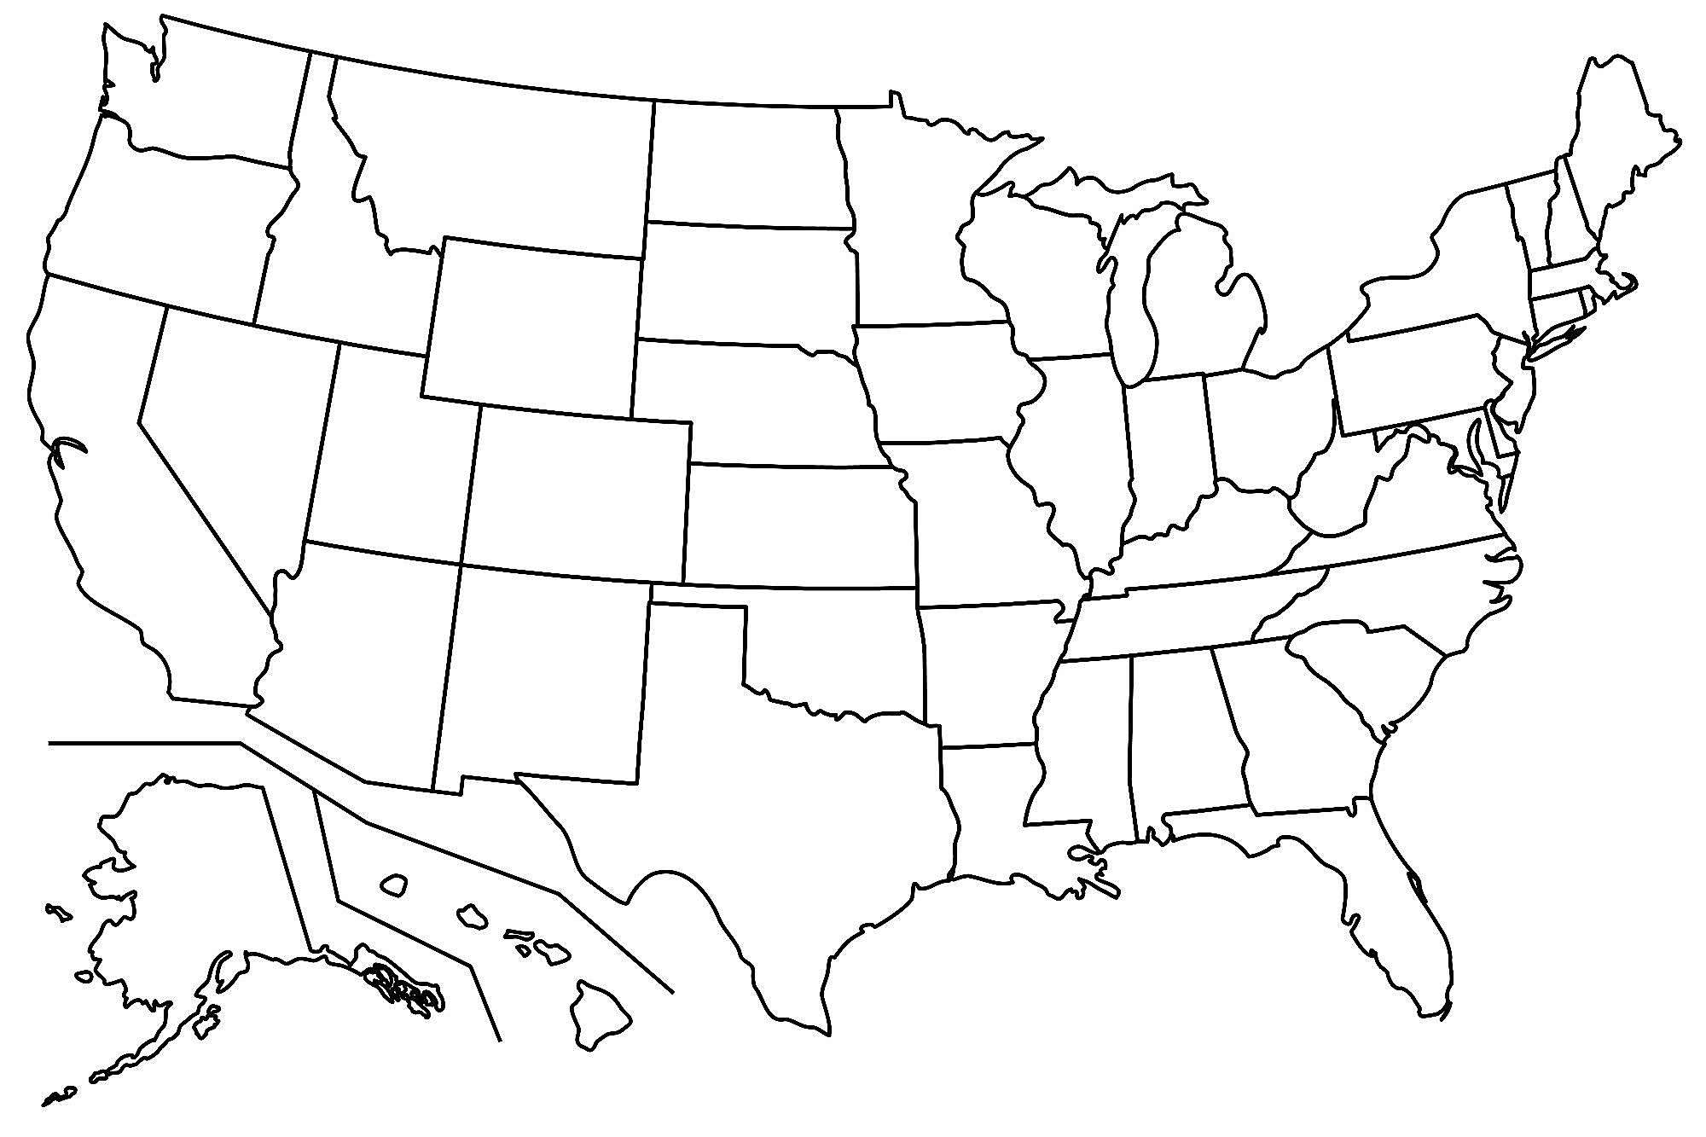Map Key:

Directions: Label the 50 states below – USE google to label map

