Name: _____________________________________ Period# ____

Directions: Fill-in the information for each of
the following Urban Models. Use the link on the class website

STATION 1

Concentric (Burgess) Model

Creator:
Year Created:
Model Definition:
Describe each of the 5 Zones | - Central Business District  - Transition Zone  - Low Income Residential  - Middle Income Residential  - Commuter/High Income Residential
Assumptions
Criticisms/Problems

Name: _____________________________________ Period# ____

Directions: Fill-in the information for each of
the following Urban Models. Use the link on the class website

STATION 2

Sector (Hoyt) Model

Creator:
Year Created:
Model Definition:
Assumptions
Criticisms/Problems

Name: _____________________________________ Period# ____

Directions: Fill-in the information for each of
the following Urban Models. Use the link on the class website

STATION 3

Multiple Nuclei Model

Creator:
Year Created:
Model Definition:
Assumptions
Criticisms/Problems

Name: _____________________________________ Period# ____

Directions: Fill-in the information for each of
the following Urban Models. Use the link on the class website

STATION 4

Model Name: Galactic  Model Creator: | History of Model: | Pros of Model:
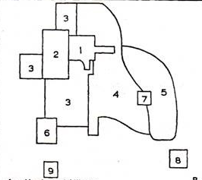
1.
2.
3.
4.
5.
6.
7.
8.
9.
 | Description of Model/How it Explains City Structure: | Cons of Model:

Name: _____________________________________ Period# ____

Directions: Fill-in the information for each of
the following Urban Models. Use the link on the class website

STATION 5

Model Name: South American City OR Griffin-Ford Model  Model Creator: | History of Model: | Pros of Model:
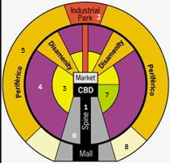
- Commercial 2. Industrial

3. Zone of Maturity 4. Zone of the Situ Accretion

5. Peripheral/Squatter 6. Elite Residential

7. Gentrification 8. Middle Class Residential

 | Description of Model/How it Explains City Structure: | Cons f Model:
Additional Questions:
- Who lives in the zone furthers from the center?

- What is disamenity sector?

- What is a shantytown?

- Where do the rich people live?

Name: _____________________________________ Period# ____

Directions: Fill-in the information for each of
the following Urban Models. Use the link on the class website

STATION 6

Model Name: African Model  Model Creator: | History of Model: | Pros of Model:
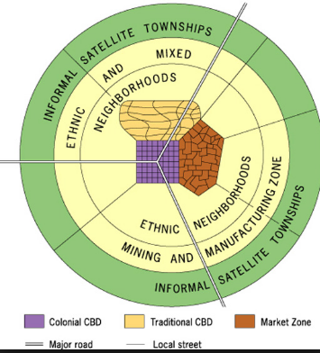

 | Description of Model/How it Explains City Structure: | Cons of Model:
Additional Questions:
- How many CBDs are there? Which is more influential?

- Which class of people live in the periphery (further away from the center)?

Name: _____________________________________ Period# ____

Directions: Fill-in the information for each of
the following Urban Models. Use the link on the class website

STATION 7

Model Name(s): Southeast Asian Model OR McGee Model  Model Creator: | History of Model: | Pros of Model:
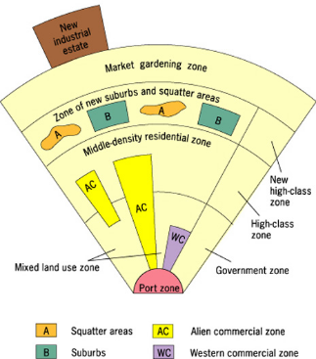
 | Description of Model/How it Explains City Structure: | Cons of Model:
Additional Questions:
- How is the focal point of this model different from all the other models?

- Where are the poorest people living in relation to the focal point of the city?

