Name: _________________________________ Period# ____ Topic 6.4

UNIT 6.4 – PRIMATE CITIES, CENTRAL PLACE THEORY, GRAVITY MODEL

WORLD CITIES
World City: (or global city) ___________________________________________________________________________, in which _______________________________________ about the world’s commercial networks and financial markets.
- Cities became centers of trade and seats of power for colonizing nations.
- Ex. ____________, Singapore, Tokyo, Hong Kong, ______________, Sydney, etc.

CENTRAL PLACE THEORY
Video Link: https://youtu.be/u5XuY04D23s

CENTRAL PLACE THEORY
- Created by Walter Christaller in the 1930’s
- The model strives to __________________________________________________________________________
____________________________________________________________________________

MARKETS
- This is an area that _____________________________________________________________, normally for the exchange of goods and services
- People _____________________________________________________________________________________

WHY USE HEXAGONS?

Answer here: ______________________________________________________________________________________
__________________________________________________________________________________________________

FINDING THE HINTERLAND

Why is time a better measure of how likely you will visit a market (such as Chipotle) compared to the distance in miles? __________________________________________________________________________________________________
__________________________________________________________________________________________________

UNDERSTANDING RANGE
- The more specialized a business or services is the ___________________________________________________
________________________________________________________

THRESHOLD
- The minimum ________________________________________________________________________________
_____________________________________________________

- Census data is used by companies to determine ____________________________________________________
_________________________________________________________
- It is important to know the demographics of the people in the threshold

PRIMATE CITY VS. RANK SIZE RULE
 | Definition | Examples
Rank-Size Rule | _____________________________ Most developed nations follow this rule unless they have a primate city. | City 1: 12/1 = 12 million  City 2: 12/2 = 6 million  City 3: 12/3 = 4 million  City 4: 12/4 = 3 million  City 5: 12/ 5 = 2.4 million
Primate City | . It should be disproportionately large and a leader in national capacity and expressions.  Good Examples: Paris, London, Cairo | 1) London = 7,172,091  - Birmingham = 970,892  - Leeds = 715,404  - Glasgow = 577,869  - Sheffield = 512,879

GRAVITY MODEL
Video Link: https://youtu.be/5z_dlC0hxbQ

THE GRAVITY MODEL
- Created by William J. Reilly in 1931
- The model predicts _________________________________________________________________________
_________________________________________________________________________________________

- Distance & population _______________________________________________________________________
__________________________________________________________________

POPULATION 1 (TIMES) POPULATION 2 (DIVIDED) BY DISTANCE (SQUARED)

What TWO factors determine the likelihood of two places (cities) interacting ___________________________________
__________________________________________________________________________________________________
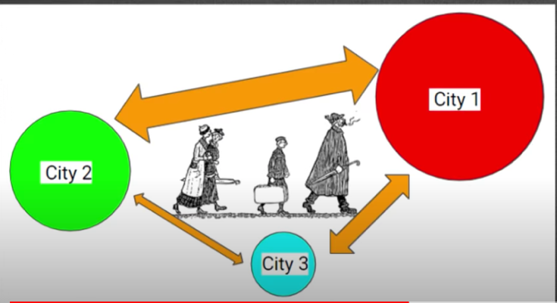
THE GRAVITY MODEL

The circles represent ____________________________________

The larger the arrow, the larger the
___________________________________________________-__

Why does ‘City 1’ interact with ‘City 2’ more
even though ‘City 3’ is closer __________________________________________________________________________
__________________________________________________________________________________________________

ASSUMPTIONS
- Uniform topography
- Uniform ____________________________________________________________________________________
___________________________________________________________________________________________
- No man-made boundaries (This would discourage people from migrating)

