Name: _____________________________________ Period# ____
Additional Review Materials on the class website – go to “Exam Resources”

www.saintcloudaphuman.weebly.com

APHUG Unit 5: Agriculture----------- Review----------Due Feb. 11th

Vocab Match-Up
Term | Definition/Example
PART 1:  _____Agriculture  _____1st Agricultural/Neolithic Revolution  _____Second Agricultural Revolution  _____3rd Agricultural Revolution  _____Domestication  _____Fertile Crescent  _____Columbian Exchange  _____Terracing  _____Irrigation  _____Deforestation  _____Draining wetlands  _____Pesticide  _____Fertilizer  _____Enclosure System  _____Mediterranean agriculture  _____Pastoral nomadism  _____Subsistence cultivation /agriculture  PART 2:  _____Commercial agriculture  _____Intensive agriculture  _____Extensive agriculture  _____Fair trade  _____Livestock  _____Agribusiness  _____Commodity chain  _____ Von Thünen Model  _____Dairy farming  _____Horticulture  _____Monocropping  _____Desertification  _____Bid -Rent Theory  _____Genetically Modified Organisms (GMOs)  _____Organic farming  _____Aquaculture  _____Sustainable agriculture  _____Local-food movements  _____Value added crops  _____Economies of scale  _____Food desert | A. Cutting down trees to use land  B.Farming  C.Farming just to feed yourself/your family  D.Human shift from hunting/gathering to farming  E.Cutting steps into hillside to create farmland  F. Ex.: Farming olives,  figs, citrus fruits, grapes  G.Subsistence ag; based on herding animals  H.Bringing water to crops by artificial means  I.Substance used to destroy insects  J.Substance added to soil to increase fertility  K.More modernization of agriculture  L.Mechanization in farming  M.Transfer of plants, animals, diseases, between Europe & the Americas  N.Region in SW Asia; hearth of agriculture  O.Clearing natural swamp areas to create fields  P.Process of taming wild plants or animals  Q. communal lands were replaced by farms owned by individuals; land was restricted to the owner or tenants  A. Group of industries dealing with agricultural produce and services required in farming  B.Farming of marine life  C.Theory: Pattern of agriculture land use  D.Growing a single crop  E.The art & science of growing plants  F.Farming a surplus for profit  G.Urban area with no grocery store nearby  H.land value determines how a farmer will use the land - intensively or extensively  I.Plants/animals with DNA altered by humans  J.Commitment to eating food produced nearby  K.Farming that does not use chemicals or GMOs  L.Provides farmers in periphery countries a fair price for their products; more equitable trading  M.Farm practices that protect the environment  N.When fertile land becomes arid over time  O.Farming that uses lots of capital on little land  P.Farming that uses few resources & more land  Q.Cost advantages when production is efficient and costs can be spread over a larger amount of goods  R.Ex.: Milk, cheese, yogurt, sour cream  S.Ex. yogurt, ground coffee, jams  T.Process used to gather resources, transform them into goods and sell them to consumers  U.Animals raised on farms for profit

Types of Agricultural Practices
Word Bank:
market gardening pastoral nomadism plantation farming
shifting cultivation mixed crop and livestock systems grain farming
slash and burn ranching

1.____________________produces fruits, vegetables, flowers that serves a specific urban area
2. ____________________growing crops like wheat, rye,corn
3.____________________both crops and livestock are raised for profit
4.____________________growing crops or grazing animals on a piece of land and then moving to a new piece of land
5.____________________clearing land then burning it to get more nutrient rich soil; then moving to a new piece of land
6.____________________breeding cattle; commercial herding of animals; extensive agriculture
7.____________________animals are moved seasonally; requires lots of land
8. ___________________ large scale farms that often crop one crop (ex. cotton, coffee)

Settlement Patterns:
9. Label the settlement as dispersed, linear, or clustered. All three types are shown.
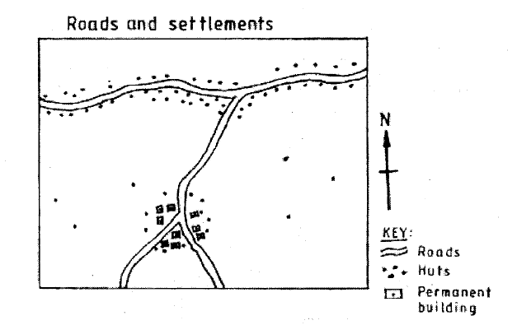
10.When people live in a linear pattern. They typically live along a ___________ or _________.

Rural Survey Methods:
11. Label these pictures: Long lot, metes and bounds, or townships

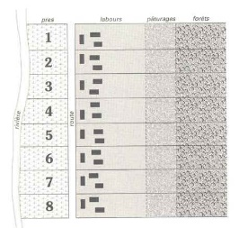
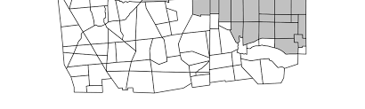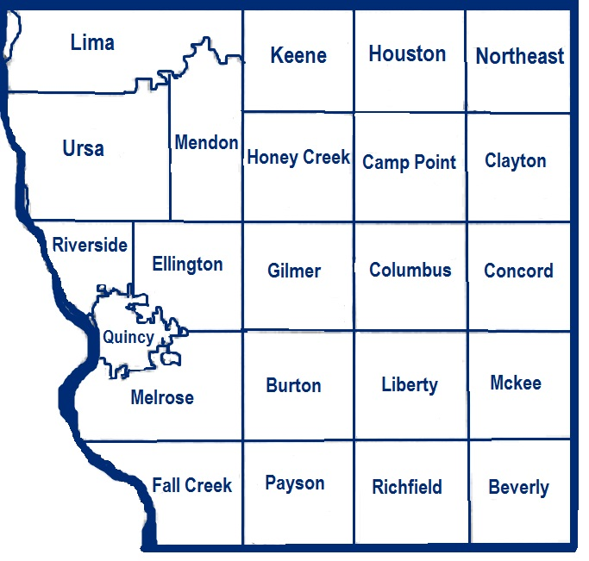

__________________________ ____________ _________________

Agricultural Hearths

12. What is an agricultural hearth? ________________________________________________

13. Circle the 8 agricultural hearths on the map below. Put a star on the Fertile Crescent.

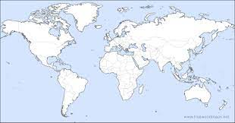
14. Where was maize first domesticated? Mexico or Africa

15. Where was wheat domesticated? Fertile Crescent or Africa

Green Revolution
16. What is TWO positive impacts of the Green Revolution? ________________________________________________________________________________________
________________________________________________________________________________________

17. What is TWO negative effects of the Green Revolution?
________________________________________________________________________________________
________________________________________________________________________________________

Agricultural Influences
18. What are two ways consumers influence agricultural practices?
- _____________________________________________________________________
- _____________________________________________________________________

19. What are two ways the government helps farmers in the United States?
- ____________________________________________________________________
- ____________________________________________________________________

20. Draw the von Thunen Model in the box below. Make sure you label all the sections.

21. The von Thunen model was created in what year? ______________

22. What is one way the model is outdated? ________________________________________________________________________________________________________________________________________________________________________________

More Vocabulary:

_____Food insecurity A. the offspring of two plants or animals of different species.
_____Suburbanization B. using living organisms to develop different products.
_____Biotechnolgy C.residences on the outskirts of a city
_____Hybrid D. tax on imported goods
_____Tariff E. possibility of not having available food
_____Infrastructure F. government payments to farmers
_____Farm subsidies G. examples: roads, bridges, ports, power supply
_____Desertification H. fertile land becomes very dry; occuring in African Sahel

True or False
23. T F Coffee is grown in the Tropics.
24. T F Because of technological innovations, less grain is produced in the 21st century.
25. T F People living in the Amazon Rainforest practice subsistence farming.
26. T F Transportation has a big impact on global supply chains

Thinking Question
27. Neo-Malthusians want to control population growth. How would a Neo-Malthusian feel about the Green Revolution?______________________________________________________________________________
________________________________________________________________________________________
________________________________________________________________________________________

Women in Farming:
Directions: Go to www.collegeboard.org and login to your account. Watch the “Topic 5.12” video on AP Classroom – then answer the attached questions.

1. Where are women heavily employed in agriculture?

2. Explain the characteristics that impact women’s role in agriculture when it comes to food production & food consumption. [NOTE: You should do more than just list what is one the screen.]
Food Production

Food Consumption

3. Describe trends in regard to female land ownership. Where is it more likely? Less likely? Why?

4. How does the DTM of different countries impact the percentage of women employed in agriculture?

5. What parts of the world [give specific regions’ have the highest percentage of undernourished populations? How does this impact women in these regions?

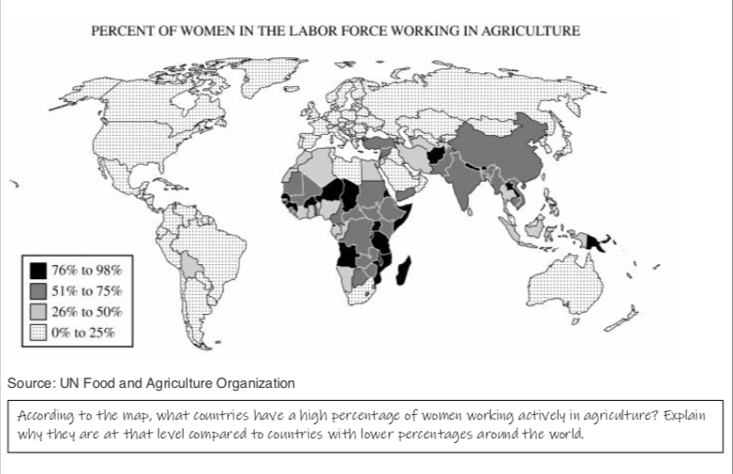
6. Explain how each of the following terms describe at least one major obstacle that prevent women in agriculture from achieving equality (education, employment, status, etc.).

1. Economic-

2. Cultural-

3. Political-

