Name: ___________________________________ Period# ____
IMPORTANT: If link is blocked, go to TEAMS, and click the video link from there

Unit 2 FINAL REVIEW
TOPIC 2.1 POPULATION DISTRIBUTION
Video Link: https://youtu.be/L8p97j55Vhw AND Pages 35 - 89 in AMSCO

- Complete the chart
Four Main Regions | Countries in this Region
Europe | England, France, Germany, Italy

- Where are population clusters located?

- What are FOUR places that people do not live?

- Complete the chart below
Arithmetic Density
Physiological Density
Agricultural Density

PRACTICE TIME!
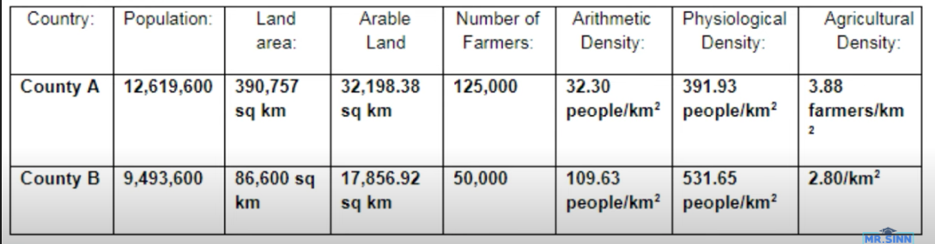

- What does the arithmetic density of the two countries show?

- Which country will put more stress on their land?

- Which country uses more efficient methods to produce food?
TOPIC 2.2 CONSEQUENCES OF POPULATION DISTRIBUTION
Video Link: https://youtu.be/yd_BSrXePZA AND Pages 35 - 89 in AMSCO

- What is carrying capacity? (page 40)

- What are TWO environmental problems often found in high population densities? (pages 42 – 43)

TOPIC 2.3 POPULATION COMPOSITION
Video Link: https://youtu.be/FyLHfW2mRaU AND Pages 35 - 89 in AMSCO

- What are population pyramids? (what do they show us) (pg. 44)

- Define the following terms
Term | Definition
Dependency Ratio
(pg. 48)
Potential Workforce
(pg. 48)
Dependent Population
(pg. 48)
Baby Boom
(pg. 46)
Birth Deficit
(pg. 46)

- How did WWII (during the war) impact population pyramids and birth rates? (pg. 45 – 46)

- What caused the baby boom? (pg. 46)

- Why do a lot of people 65 and older move to Florida – creating longer bars on a population pyramid? (pg. 47)

- Why would bars on a population pyramid be longer for males than females? (pg. 47)

TOPIC 2.4 POPULATION DYNAMICS
Video Link: https://youtu.be/4bvZW0v2ynM AND Pages 35 - 89 in AMSCO

- Complete the chart
Term | Definition
Crude Birth Rate (CBR) | The ______________________________________________________ for every 1000 people alive in the society.
Total Fertility Rate (TFR) | The ___________________________________________________________________ throughout her childbearing years.
Crude Death Rate (CDR) | The total number of deaths in a year for every 1000 people alive in the society.

- How to calculate natural increase rate (NIR)?

- Natural Increase Rate (NIR) - The percentage growth of a population in a year, computed as the crude birth rate minus the crude death rate.

- Natural Increase Rate (NIR) = (__________________) – (____________________)
10

Country | Birth Rate | Death Rate | Natural Increase Rate
United States | 14 per 1000 | 8 per 1000
Kenya | 40 per 1000 | 12 per 1000
Mexico | 21 per 1000 | 5 per 1000
India | 24 per 1000 | 8 per 1000

- How to calculate doubling time?

- Doubling Time - The ______________________________________________________, assuming a constant rate of natural increase.

- Doubling Time (in years) = ______________ 70___________________
Rate of Increase

Country | Doubling Time
United States
Kenya
Mexico
India

TOPIC 2.5 THE DEMOGRAPHIC TRANSITION MODEL
Video Link: https://youtu.be/5hWRFwQ_pE4 AND Pages 35 - 89 in AMSCO
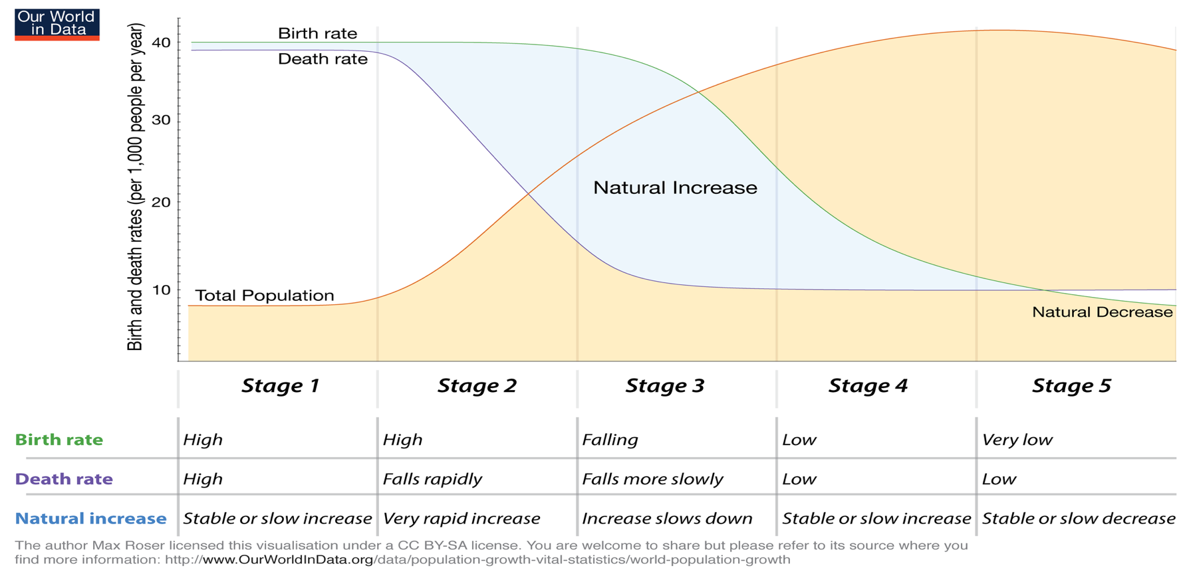

- Complete the chart below by showing the characteristics in each stage
 | Stage 1 | Stage 2 | Stage 3 | Stage 4 | Stage 5
Birth Rate |  |  |  |  | Very Low
Death Rate |  |  |  |  | Low
Natural Increase Rate (NIR) |  |  |  |  | Declining
Life Expectancy and Health |  |  |  |  | High
Role of Women | Traditional Roles | Traditional Roles | Opportunities in society begin | Economically and socially empowered
Economy | Subsistence Farming | Agriculture | Manufacturing | Service Industries (Quaternary & Quinary
Example | Sentinelese people (no countries exist) |  |  |  | Japan, Russia
Epidemiological  Model  Define: causes of death in each stage of the demographic transition. |  |  |  |  | Stage of Re-emergion of infectious and parasitic diseases  Consequences: higher CDR

- Label what types of population pyramids are found above (expansive, stationary, constrictive)

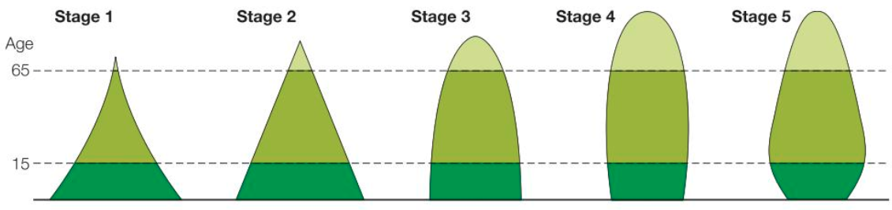

TOPIC 2.6 MALTHUSIAN THEORY
Video Link: https://youtu.be/NiLNpoNkekw AND Pages 35 - 89 in AMSCO

- What did Thomas Malthus predict? (pg. 67)

- Why was Thomas Malthus wrong? Explain why his prediction was wrong (pg. 67)

TOPIC 2.7 Population Policies
Video Link: https://youtu.be/Iesg3pZow2Y AND Pages 35 - 89 in AMSCO

- Complete the chart – provide a definition and an example (pg. 59 AND pg. 57)
Term | Definition | Example
Pro-Natalist Policies
Anti-Natalist Policies

- What type of country would implement pro-natalist policies (less or more developed AND what stage(s) of the DTM? (pg. 59)

- What type of country would implement anti-natalist policies (less or more developed AND what stage(s) of the DTM? (pg. 57)

TOPIC 2.8 WOMEN AND DEMOGRAPHIC CHANGE
Video Link: https://youtu.be/DWJjJnrqouo AND Pages 35 - 89 in AMSCO

- What are 2 reasons why total fertility rate (TFR) typically falls during stages 3 and 4 of the DTM? (pgs. 56 -57)

- What are Ravenstein’s Laws of Migration? (pg.77)

- Describe some of Ravenstein’s Laws of Migration (pgs. 77 – 78)
Type of Law | Description
Short Distances
Urban Areas
Multiple Steps/Step Migration
Gender Patterns

TOPIC 2.9 AGING POPULATIONS
Video Link: https://youtu.be/2IdgoY54qdw AND Pages 35 - 89 in AMSCO
- Explain the 3 reasons why life expectancy has increased over the last 100 years (pgs. 60 – 61)
Reason | Explanation/Description
Better Food Production and Nutrition
Improvements in Sanitation
Improvements in Healthcare

TOPIC 2.10 CAUSES OF MIGRATION
Video Link: https://youtu.be/Xp70BrhYkuQ AND Pages 35 - 89 in AMSCO
- Define the terms below (pg. 73)
Term | Definition
Push Factor
Pull Factor

- Provide examples for the different types of push and pull factors (pgs. 74 – 75)
Example | Push | Pull
Economic
Social
Political
Environmental
- What are intervening obstacles? (pgs. 76 – 77)

TOPIC 2.11 FORCED AND VOLUNTARY MIGRATION
Video Link: https://youtu.be/p4ddOH4LvJE AND Pages 35 - 89 in AMSCO

- Define and provide an example for the terms below (pg. 73 and pg. 79)
Term | Definition | Example
Voluntary Migration
Forced Migration

- Explain the difference between ‘internally displaced persons’ and ‘refugees?’ (pg. 80)

- Explain the difference between ‘step migration’ and ‘chain migration?’ (pgs. 77 – 80)

TOPIC 2.12 EFFECTS OF MIGRATION
Video Link: https://youtu.be/ZHDvZMplnQg AND Pages 35 - 89 in AMSCO

- Define and provide an example for the following terms
Term | Definition | Example
Acculturation
(pg. 100)
Assimilation (pg. 100)
Xenophobia (pg. 82)
Remittance (pg. 83)
Brain Drain
(pg. 82)

