Name _________________________________ Period# ____

Unit 1 FRQ

Write in blue or black ink. Use complete sentences and correctly label your response. You may write on this page to brainstorm and plan your response.

Remember, “identify” and “define” require a minimum of 1 complete sentence; “describe,” “explain” and “compare” require a minimum of 3 complete sentences AND use ACE TEMPLATE

Map X Map Y
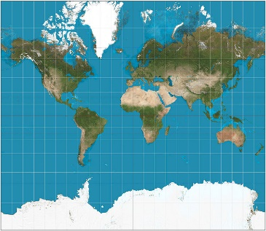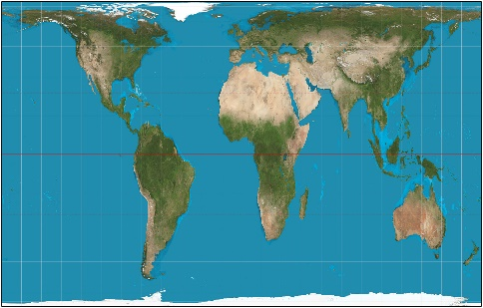

- Identify the Mercator projection and Gall Peters map projection
- Describe one advantage of using the Mercator projection.
- Describe one disadvantage of using the Mercator projection.
- Describe one advantage of using the Peters projection.
- Describe one disadvantage of using the Peters projection.
- Explain why all map projections have some type of map distortion
- Explain why Google Maps uses the Mercator projection.

Write your responses below

________________________________________________________________________________________________________________________________________________________________________________________________________________________________________________________________________
________________________________________________________________________________________________________________________________________________________________________________________________________________________________________________________________________________________________________________________________________________________________________________________________________________________________________________________________________________________________________________________________________________________________________________________________________________________________________________________________________________________________________________________________________________________________________________________________________________________________________________________________________________________________________________________________________________________________________________________________________________________________________________________________________________________________________________________________________________________________________________________________________________________________________________________________________________________________________________________________________________________________________________________________________________________________________________________________________________________________________________________________________________________________________________________________________________________________________________
________________________________________________________________________________________________________________________________________________________________________________________________________________________________________________________________________________________________________________________________________________________________________________________________________________________________________________________________________________________________________________________________________________________________________________________________________________________________________________________________________________________________________________________________________________________________________________________________________________________________________________________________________________________________________________________________________________________________________________________________________________________________________________________________________________________________________________________________________________________________________________________________________________________________________________________________________________________________________________________________________________________________________

