Name: ______________________________ Period# ___ Topic 7.7 Changes as Result of the World Economy

Offshoring | Outsourcing`
- ________________________________________  ________________________________________  ________________________________________  ________________________________________  - I.e. software and manufacturing companies in the US and Europe that ____________________  ________________________________________. | - Outsourcing is contracting work out to non-company employees of other companies  - This can be international or domestic  - i.e. A German car company contracting with a Chinese supplier to make a part  - (As opposed to vertical integration)

Deindustrialization
- ______________________________________ (like the US) ___________________________________
_________________________________________
- These economies have ________________________________________________________________.
- This has impacted the landscape by creating brownfields/rust belt and through the development of corporate parks (commercial spaces for headquarters).

Export Processing Zones
- Industrial areas where the government creates specialized policies and desirable investment and/or _______________________________________________________________.
- Uses _____________________________.
- Often near ____________, _____________, or _______________________________________.
- Maquiladoras are factories built by a US company in Mexico near the US border, taking advantage of the lower labor costs and tax breaks.

Special Economic Zones
- A specific area within a country in which ______________________________________ are implemented to _________________________ (and domestic) businesses and investment.
- Examples: __________________________________________________________________________________

Why China Wins at Exporting
Video LINK: https://youtu.be/E7Jfrzkmzyc
- What percentage of global economic activity is China responsible for? _______________

- Areas in a country like China in which there are tax incentives and less regulation are known as _______________________________________.

- Shenzhen is a good example of agglomeration because it _____________________________________________________________
________________________________________________.

- Where does the middle class grow best? ___________________________.

- As factories become more automated and need less workers, why may US transnational corporations bring their production back to the US? _____________________________________________________________________________________________________
____________________________________________________________________________________________.

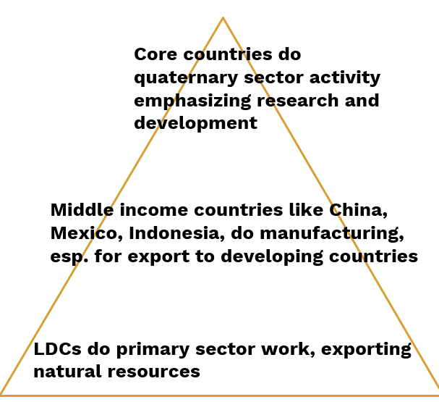
New International Division of Labor
- ‘Traditional’ division of labor - one employee does one part of the production process.
- New International Division of Labor ___________________________
________________________________________________________
________________________________________________________

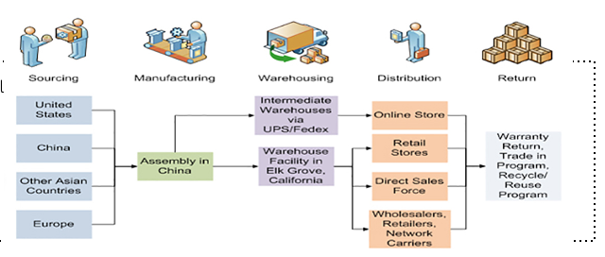
The New International Division of Labor spreads out the commodity chain…
- _______________________________________
________________________________________ and resulting in a commodity that is then exchanged on the world market

Post-Fordist Production
- Fordist production - _______________________________
Impact on Landscape?
Smaller footprint (thanks to JIT)
Demands skilled labor - site factor
- Flexible production
- Workers operate in teams and figure out their tasks through problem solving
- _________________________
- _____________________

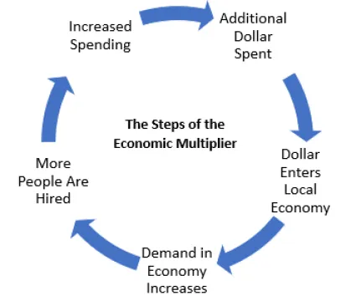
Multiplier Effect
Basic Jobs | Non-Basic Jobs
Provide __________________________  _________________________________  _________________________________  _________________________________, bringing money into their respective communities from the outside.  Ex. car manufacturer | ________________________________  _________________________________  _________________________________. They do not generate money from outside sources.  Ex. waitress

Economies of Scale
- A _________________________________________________________________________________________
- The ________________________________________________________________
- Cost is reduced when companies increase production because the fixed costs are spread over more units of production
- Example: Walmart

Growth Poles | Technopole
- A place of concentrated ________________________  ____________________________________________  ____________________________________________  ___________________________  - Each new business strengthens the pull of the ‘magnet’  - (Can lead to brain drain for areas outside the growth pole) | - A ____________________________  - A hub for information based industry and high tech manufacturing  - _________________________________________ well known for computer, math, engineering, science  - Example: Silicon Valley California

