Name: ______________________________ Period# _____ Topic 3.7 Diffusion of Language
3.7 Explain what factors lead to the diffusion of language.
- Language families, languages, dialects... diffuse from cultural hearths.
- Diffusion of language families, including Indo-European...and distributions can be visually represented on maps, in charts and toponyms, and in other representations.

Warm-up:
- How many languages are there? _______________
- List the top 5 native spoken languages on the planet? (in order) __________________________________
_______________________________________________________________________________________
Correct Answers:
- __________________
- _______________________________________________________________________________________
_______________________________________________________________________________________
What is language?
- Linguistic geographers _____________________________________________________as well as their distribution and relationships between one another.
- Language is a _____________________________________________________________________________
Classifying Languages
Language Family: __________________________________________________________________________, _________________________and trace back to a common hearth.
- Indo-European is the largest language family with about 3.2 billion speakers distributed across the world.
- Sino-Tibetan is the second largest with 1.4 billion speakers mostly concentrated in East and Southeast Asia.

Language Branch: __________________________________________________________________ from thousands of years ago. They were separated from other languages in their family and now are distinctive although related.
- ________________________: Includes languages like ______________, Portuguese ________________ and Italian.
- Germanic Branch: Includes languages such as German, English, and Dutch.

Language Group: ___________________________________________________________________ with ____________________________________ and some overlap.
- Similarities between Portuguese, Italian and Spanish.
- West Germanic languages such as Dutch and Afrikaans will have more similarities than with their North Germanic ancestors and vice versa.

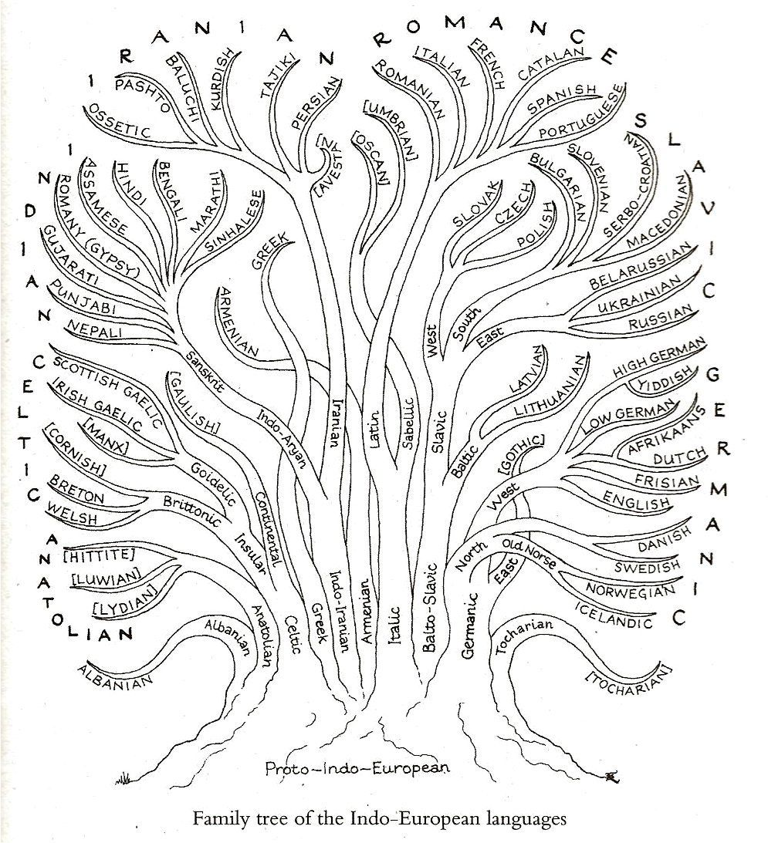
Language Tree (Family, Branch, Group, Language, Dialect)
Sound Shift
- Sound shift _____________________________________________________________________________ or through a language family from the present backward toward its origin
  - Ex.: Italian, Spanish and French as members of the Romance language subfamily
  - Example:
    - Milk =lacte in Latin
    - latta in Italian
    - leche in Spanish
    - lait in French

Dialects: Variation of a standard language distinguished by _________________________________________________, _____________________, speed, and _______________. Smallest amount of speakers - develop due to migrations and isolation from original language.
Example: South = Y’all, North = You guys

Isogloss: A _____________________________________________________________ feature occurs. Lines that ________________________________.
Dialects across America | LINK: https://youtu.be/4HLYe31MBrg
Provide at least 3 examples of different dialects across the United States?

