Name: ________________________________________ Period# _____ Topic 2.5 Epidemiological Transition Model
Epidemiological Transition Model
- Epidemiological Transition Model (ETM): Predictable stages in _________ and ____________________________ that countries experience as they develop which ___________________________________________________.
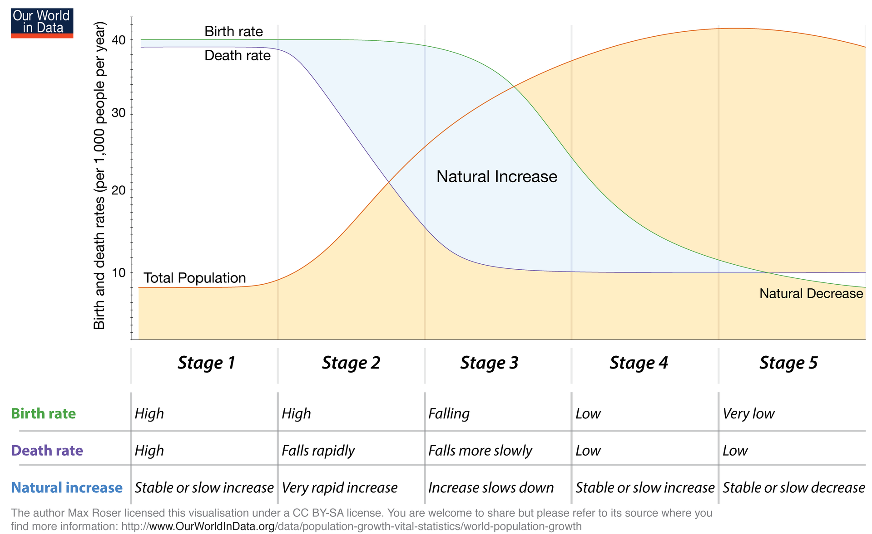

Pestilence & Famine (Stage 1) | Receding Pandemics  (Stage 2) | Degenerative & Human Made Diseases (Stage 3) | Delayed Degenerative Diseases (Stage 4) | Reemergence of Infectious Disease (Stage 5)
Infectious Diseases  - Cholera  - Tuberculosis  ______________ & _______________  Animal Attacks & _______________  ________________ | Pandemics and _________________  _________________  _________________ due to new medical advances, sanitation and improved nutrition. | Diseases __________  __________________  __________________  __________________  __________________.  Examples:  Heart Disease  Cancer | Diseases associated with ____________  ________________  ________________  ________________  ________________  ________________  ________________.  Examples: Alzheimer's  Dementia | ___________ and _________________  _________________  _________________  _________________  _________________.  Reemergence of infectious diseases.  Examples:  Ebola  COVID-19

Name: _________________________________ Period# _____
Directions: For each scenario below, write what stage from the Demographic Transition Model it represents
Scenario | Stage | Scenario | Stage
Billy White loses his job a grave digger |  | New home construction is rapidly increasing
Parents start to think more about family planning |  | The public health inspector smiles as the buildings sewer system is completed
Children are warmer in bed each night because they have more brothers and sisters |  | Fewer children share a bedroom
There are more Golden (50 years) anniversaries being celebrated |  | Grandparents are very rare
A mother sobs over the grave of her last six children who died because of smallpox |  | There are more grandparents than grandchildren
Women begin to earn college degrees and obtain jobs |  | Death Rate Falling Rapidly
Extremely Low Birth Rate, Low Death Rate |  | The United States
Continued medical advancements, enhanced welfare provisions, economic independence of women, and improved access to contraceptives is seen in stage |  | Improved sanitation, children seen as an asset, mechanization, and population explosion are characteristics of stage

