Name: _______________________________ Period# _____ Topic 2.4 – Population Dynamics
2.4 Explain factors that account for contemporary and historical trends in population growth & decline.
- Demographic factors that determine a population’s growth and decline are fertility, mortality and migration.
- Geographers use the rate of natural increase and population doubling time to explain population growth and decline.

What factors determine a population’s growth & decline?
Fertility | Mortality
- Crude Birth Rate (CBR)  - The ________________________________  ___________________________________ per 1,000 people.  - Total Fertility Rate (TFR)  - ____________________________________  ____________________________________  ______________________________ during her childbearing years.  - Globally TFR has been significantly decreasing over time. | - Life Expectancy  - The number of years the average person will live.  - This has _____________________________  ____________________________________  _______________________________.  - Crude Death Rate (CDR)  - The number of deaths occurring in one year per 1,000 people.  - Infant Mortality Rate (IMR)  - The _________________________________  _____________________________________  _______________________________.  - Typically, when IMR goes down, life expectancy goes up which leads to higher population growth.

How do geographers calculate population growth & decline?
- Natural Increase Rate (NIR) or Rate of Natural Increase (RNI) - _________________________________________
_____________________________
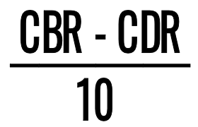
  - Does not account for migration.
  - _________________________________, indicating population decrease.
  - Usually expressed in a percentage

- Doubling Time: ________________________________________________________________________________
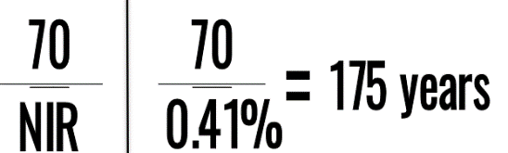
________________________________.

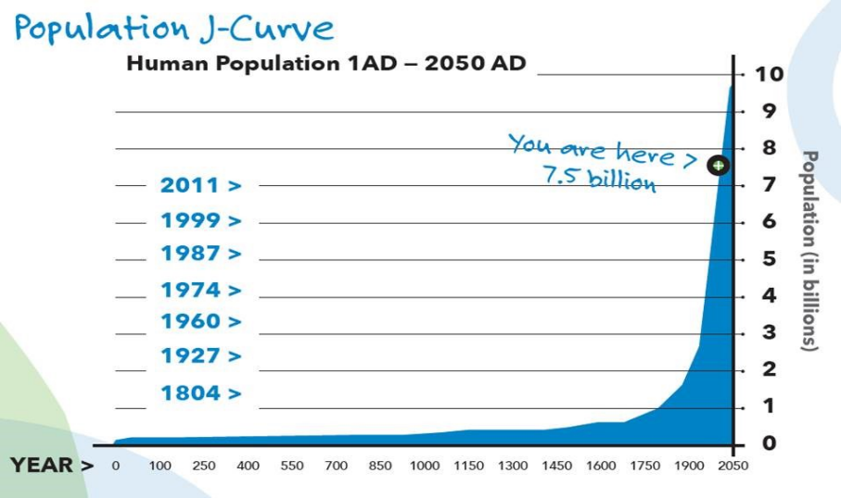
What created the population boom?

When did the population boom begin?

Where is most population growth taking place?
2.4 Explain factors that account for contemporary and historical trends in population growth & decline.
- Social, cultural, political, and economic factors influence fertility, mortality and migration rates.

What causes population to grow & decline?
E  C  O  N  O  M  I  C | POPULATION GROWTH  - ________________________________  - Need children to labor on the farm  - Advancements in ______________________  ______________________ & nutrition  - Mechanization of agriculture  - Farming efficiency  - Advancements ________________________  - Less water contamination & disease  - Water treatment plants  - __________________________  - Economic prosperity  - Access _____________________________  - Core __________________________  _______________________________  - Prevention & cure of disease.  - Women have access to pre & post-natal care | POPULATION DECLINE  - Industrial & post-industrial society  - Women ___________________________  __________________________________  - Urbanization -> small living quarters  - Economic hardship  - Children are ____________, provision of food & resources  - Access to healthcare  - Women ____________________________  __________________________
S  O  C  I  A  L | POPULATION GROWTH  - Religion  - __________________________________  _________________________  - ___________________________ use and ___________________.  - Earlier marriages = more children | POPULATION DECLINE  - Role of Women - ______________ & Workforce  - Cultural expectations have changed in many MDCs _______________________  ___________________________________ -> postpone having children -> reduction in child bearing years -> less children.  - Healthcare  - How to care for babies -> _____________, CDR, _____________________________  - Access & understanding of contraception -> __________________________

