Name: ___________________________________ Period# _____ Topic 2.12 Effects of Migration
Topic 2.12 Explain historical and contemporary geographic effects of migration.
- Migration has political, economic, and cultural effects.

Economic Effects of Migration
RECEIVING COUNTRIES | COUNTRIES OF ORIGIN
- Immigrants __________________________________  ___________________________________________.  - ________________, ___________________, service industries  - Reduce available jobs for citizens of the country.  - Immigrants often open businesses.  - Shops, restaurants, nail salons | - Decrease in _______________________.  - Less strain on resources.  - Remittances support the economy.  - Brain drain: ________________________________  __________________________________________  _______________________________  - ______________________________ in the US are born in another country.
Case Study: The Philippines
In 2017, 10% of the country’s GDP came from remittances which totaled $33 billion.

Social & Demographic Effects of Immigration
RECEIVING COUNTRIES | COUNTRIES OF ORIGIN
- Cultural Contributions: ________________________  ___________________________________________  ___________________________, food, literature, religion, language, art, etc.  - This _________________________________  _____________________________________  _________________________. Prejudice, discrimination, racism, etc.  - Demographic Change  - Stage 4 & 5 countries are low growth, zero growth or population decline.  - Since the 1990s, _______________________  _____________________________________  ______________________ in core countries.  - Age Composition: Most immigrants are working age which reduces the dependency ratios and provides tax support for the young and elderly. | - Demographic Change  - Unbalanced sex ratio: Typically, __________  ____________________________________  ________________________, which leaves a shortage of men in the country of origin.  - Dependency ratio: Oftentimes the young and the elderly are left behind.  - Changes the traditional family structure  - Relief _____________________________________

Political Effects of Immigration
RECEIVING COUNTRIES & COUNTRIES OF ORIGIN
- Immigration Restrictions: __________________________________________________________________ or the desire to limit cultural diversity.
  - Japan and the United States
- Laws that encourage immigration
  - _______________________________________
  - _______________________________________
Case Study: The Chinese Exclusion Act, 1882-1943
The first law that severely restricted immigration in the US.

Examples of Migration in the United States
- Changing Center of U.S. Population – the population center ______________________________________________
_______________________________________________________________________________________________
Current Trend: Southwest motion
1790
1850 - 1890
1950 - 2010
1900 - 1940
1800-1840

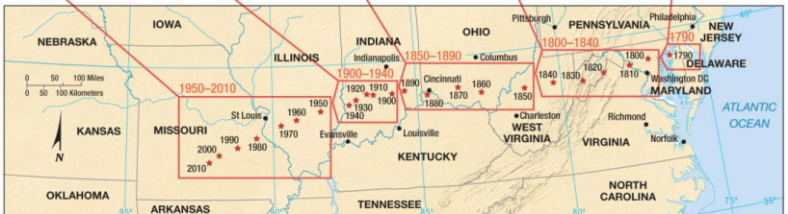

Rust Belt vs Sun Belt:
- The Rust Belt ________________________________________________________, they would close as manufacturing went overseas
- Sun Belt are southern states – ______________________________________________________________________
_____________________________________________

The Great Migration: https://www.youtube.com/watch?v=VCdTyl141bA

- What was the Great Migration?

- Why did blacks leave the South? (what reasons)

- What caused blacks to return to the South?

