Name: _______________________________________ Period# _____
Topic 1.1 – Introduction to Maps
1.1 Identify types of maps, the types of information presented in maps, and different kinds of spatial
patterns and relationships portrayed in maps.
- 1.1.1 Types of maps include reference maps and thematic maps.
- 1.1.2 Types of spatial patterns represented on maps include absolute and relative distance and direction, clustering, dispersal, and elevation.
- 1.1.3 All maps are selective in information; map projections inevitably distort spatial relationships in shape, area, distance, and direction.

TOPIC 1.1.1
- Reference Maps - general information/navigation/location
  - Political - _______________________________________________________________
  - Physical- _______________________________________
  - Road- _____________________________________
2. Thematic Maps- _____________________________________________________________________ - what is it like there?
Examples of Thematic Maps | Definition | Image
Dot- Density | ____________ of a spatial characteristic. | 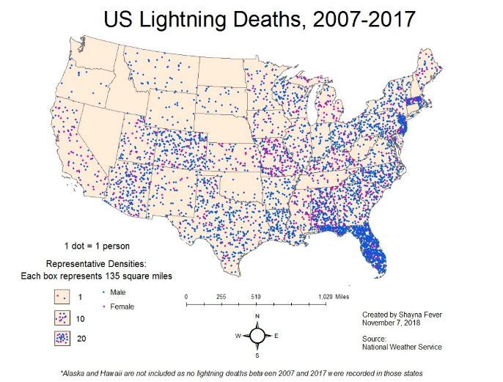
Graduated/ Proportional Symbol | ____________ of  a variable. | 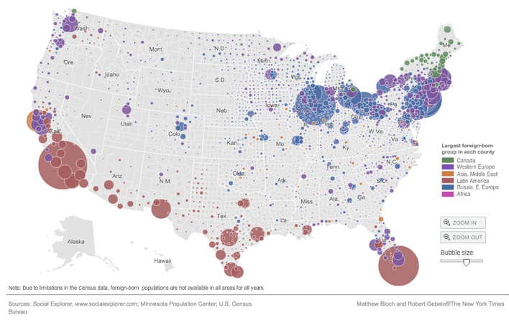
Cartogram | ____________. Area is distorted to show a variable. | 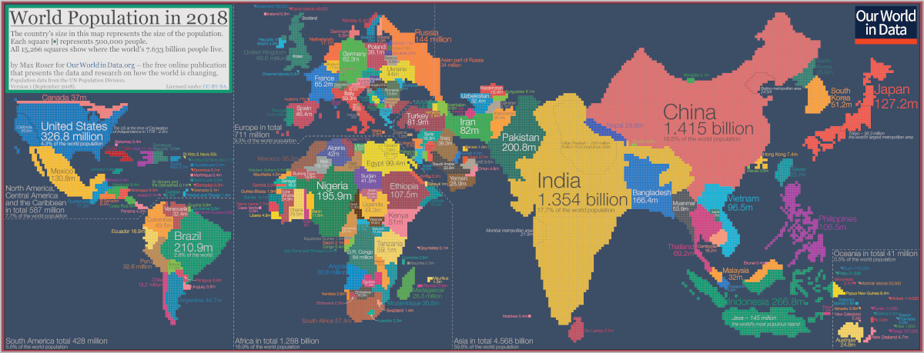
Isoline | Use lines that connect points of equal value to depict variations in the data across space. | 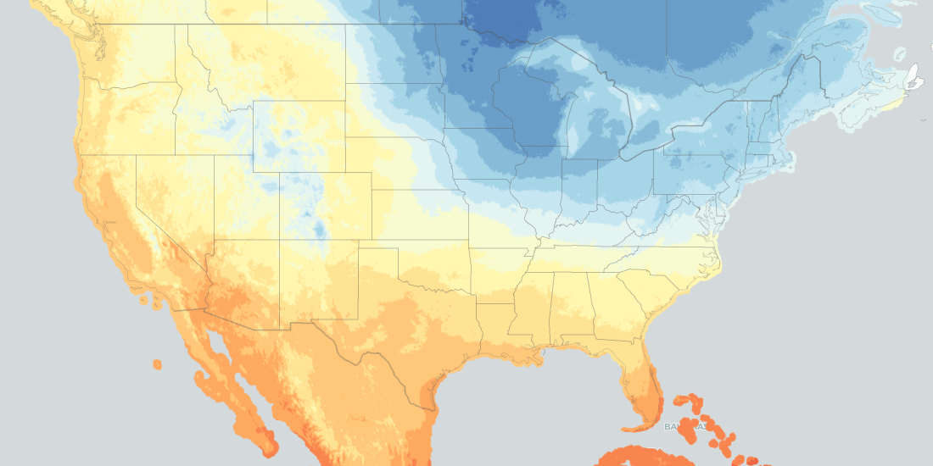
Elevation | Elevation shown through lines & their distance apart. | 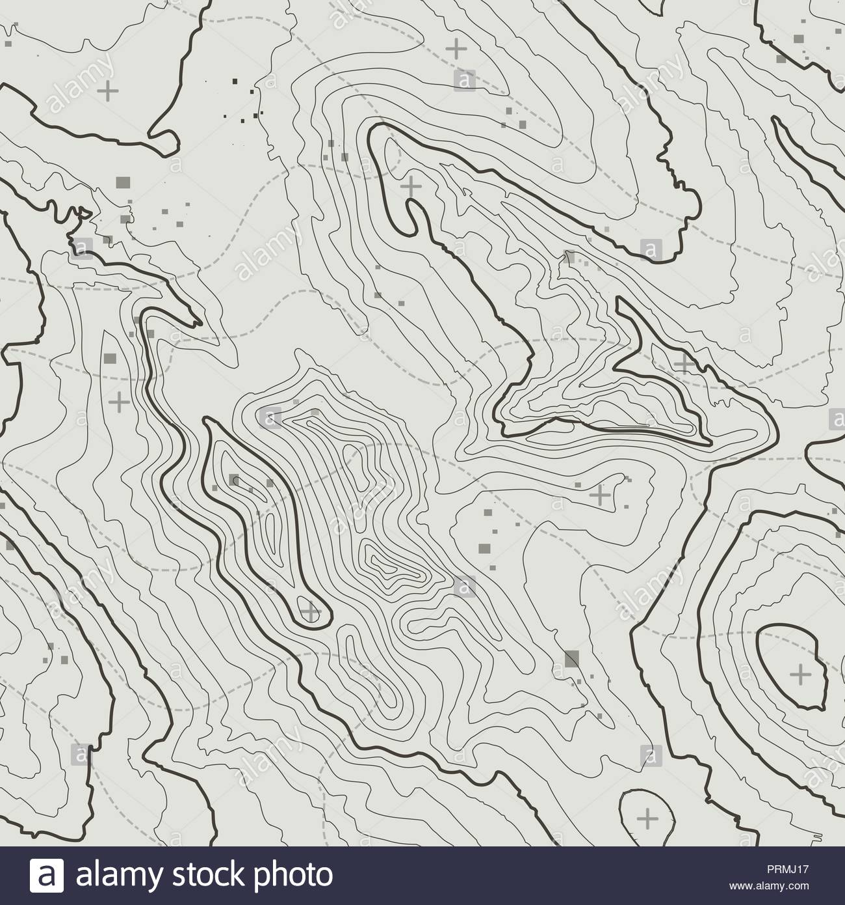

TOPIC 1.1.2
LOCATION | DISTANCE
- Absolute Location  - _______________________  - ______________  - _____________________________  - Rio de Janeiro is located at 23°S, 43°W.  - Relative Location  - Relationship to another place  - _________________________  - Between New York & Pennsylvania Ave. | - Absolute Distance  - EXACT, PRECISE  - Miles/Kilometers/Feet  - ______________________________________  ______________________________________  - Map Scale  - Relative Distance  - Spatial Interaction: Connections, contacts, movement, and flow of things between places.  - __________________________________  __________________________________  __________________________________  - I can order anything on Prime and have it delivered to my house in two days!
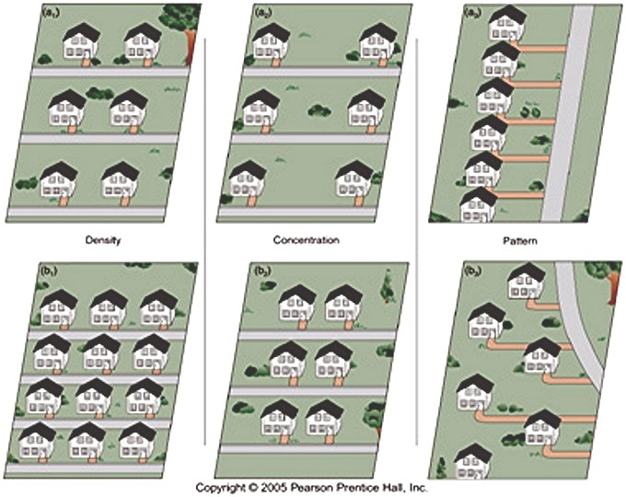
- Clustering
  - ________________________
  - Density - The # of something in a
defined area.
- Dispersal/Distribution
  - ______________________
  - Distribution - The way something is
spread out over an area.
- Pattern & Spatial Associations
  - ____________________________________
____________________________________
____________________________________
, associated, or correlated
with one another.
TOPIC 1.1.3
Map Projection: The process of a cartographer (map maker) showing the curved surface of the earth on a flat surface (map).
Type of Map Projection | Advantages | Disadvantages | Image
Mercator | - ____________  - ____________  - Purpose: _____________  - Preserves right angles of latitude and longitude. | - _________________  _________________  _________________  - Increases size of high latitude areas. | 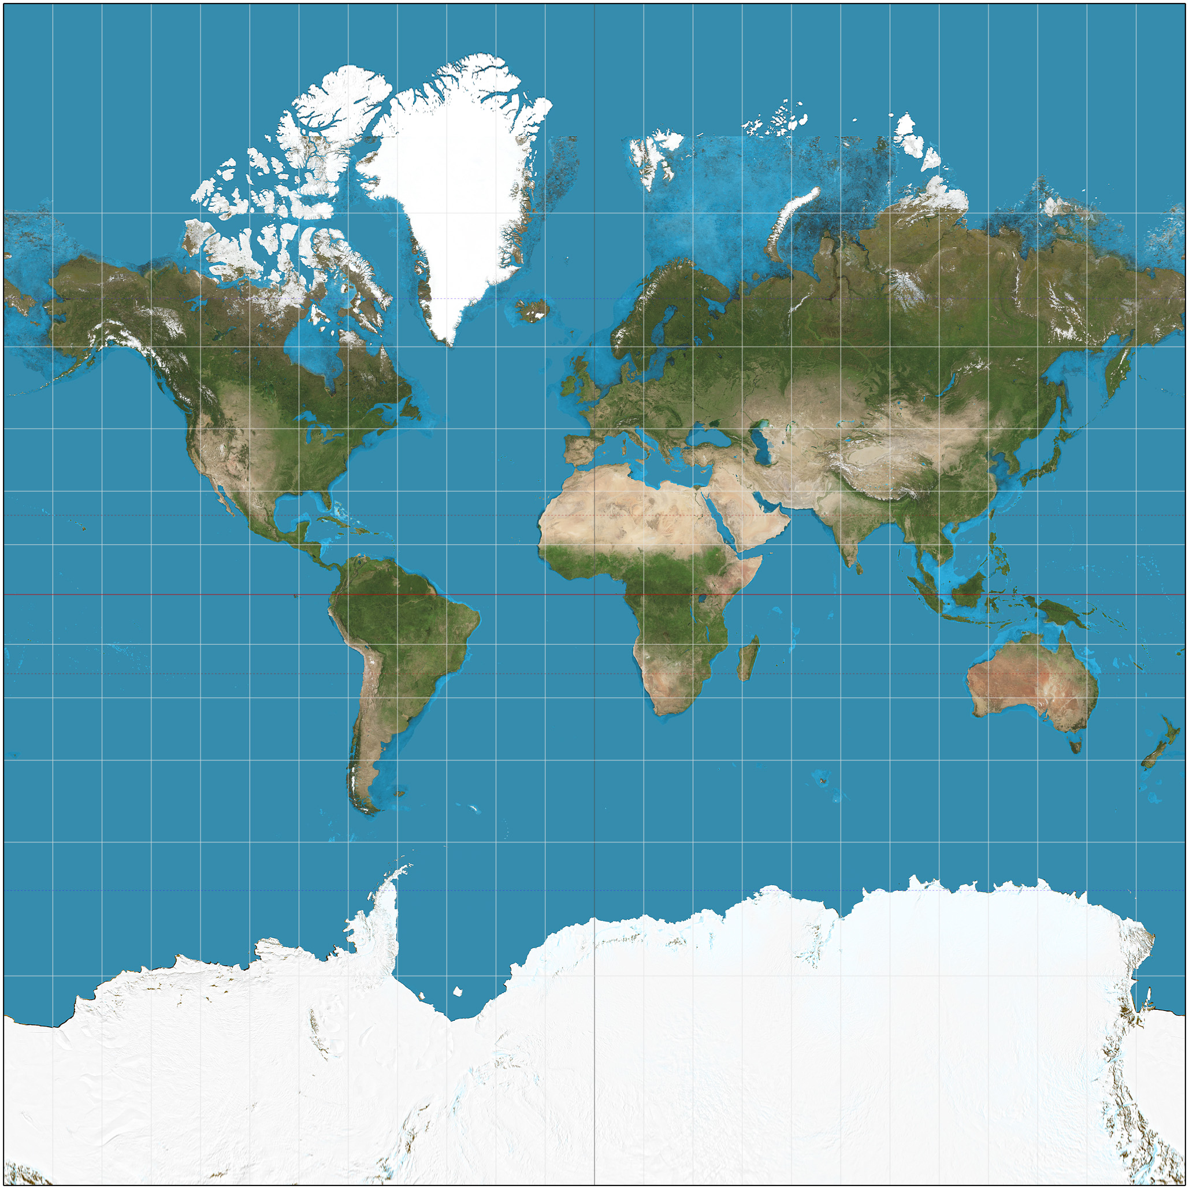
Gall-Peters | - Area of landmasses are accurate.  - Repositions many countries to their rightful size. | - _________________  _________________ near the poles.  - Vertically stretched near the equator. | 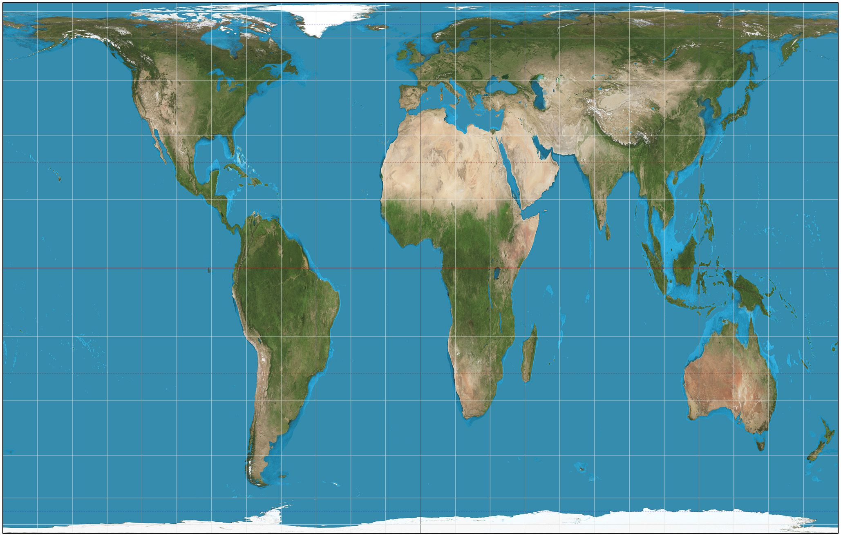
Robinson | - No major distortions  - _____________  ______________ | - _________________  _________________  _________________ | 