Name: ____________________________________________ Period# ______ Intro to Culture – Taboos

Taboos and Tattoos

What are taboos? Watch the following video https://youtu.be/TQP0jjSMRgc

Pre-Reading Discussion Questions:

- What are your own personal beliefs about tattooing? What has influenced your ideas of tattoos?

- How does your particular cultural group view tattoos (ethnic, religious, youth vs. adults, etc.)

- Based off your ideas what do tattoos reveal about a person/person’s decisions.

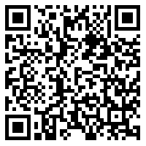

Article “Taboos and Tattoos Link: https://tinyurl.com/y4v2jhdz
Reading Questions:

- What are the Mormon’s views towards tattoos and their reasoning for those views?

- What are the Polynesians views towards tattoos and their reasoning for those views?

- Which set of views most closely corresponds to your own beliefs of tattoos? Explain how.

