Part 1: Instructions – Choose a color to represent each item within the key. Then, color each of the colonies of Africa listed on the right, using the color key you created.
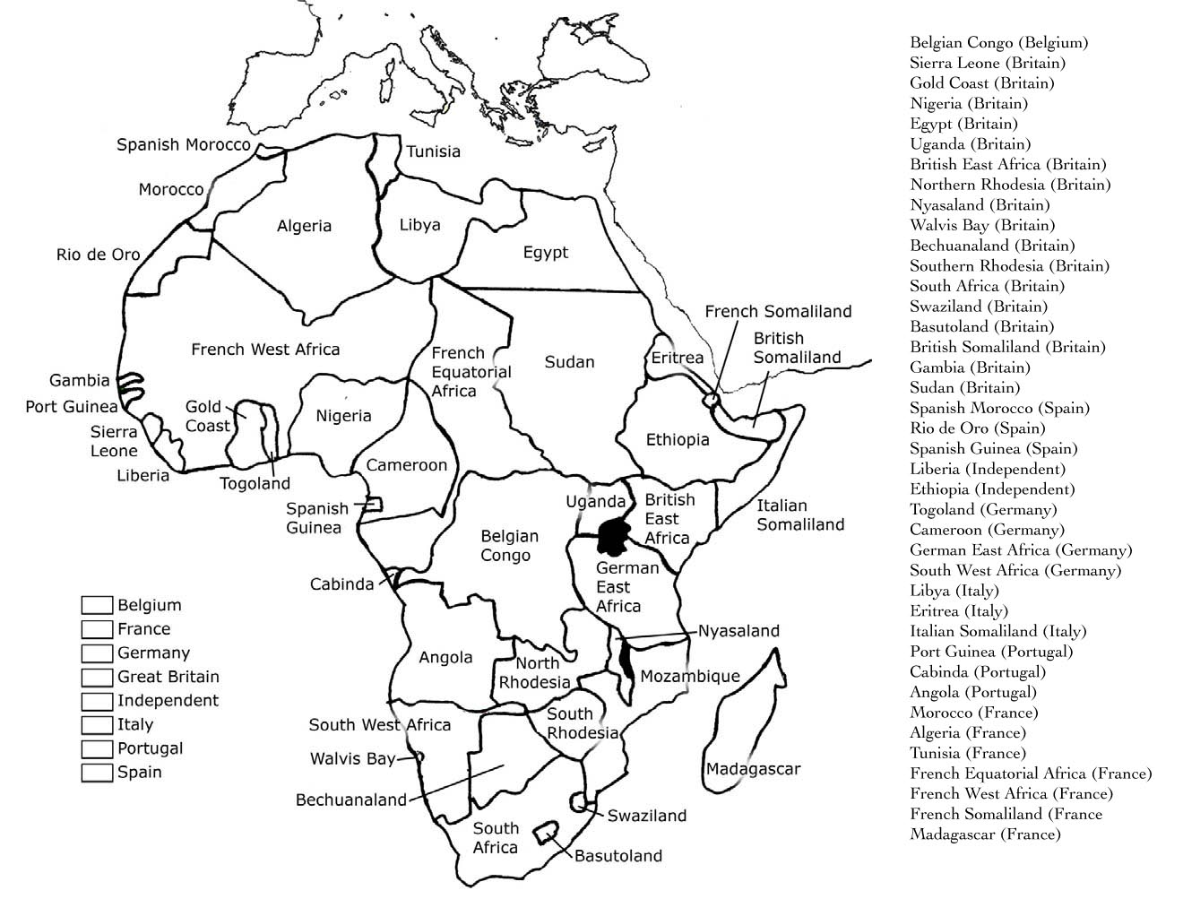

Answer the following questions using the above map:
- Which two countries held the most land in Africa? How many did each have? _____________________
____________________________________________________________________________________
- Which country held the least land in Africa? How many did it have? ____________________________
- Which African nations managed to resist colonization? _______________________________________
AFRICA AFTER THE BERLIN CONFERENCE
AFRICA BEFORE THE BERLIN CONFERENCE

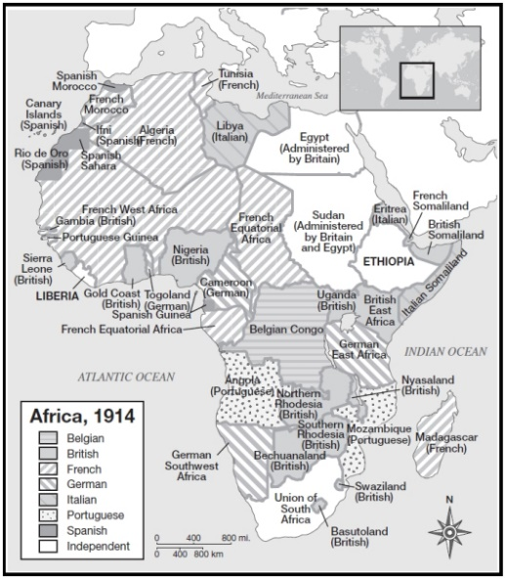
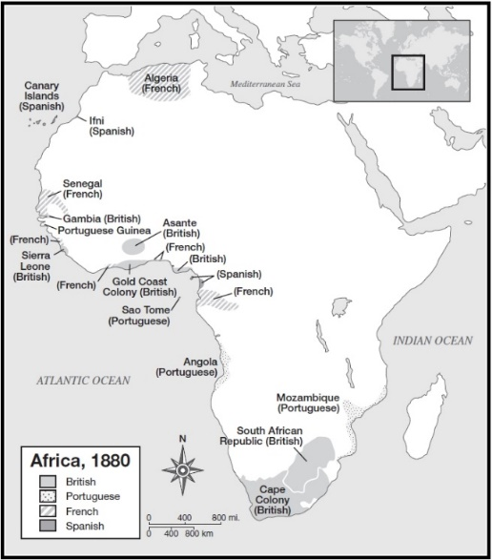

"The Berlin Conference was Africa's undoing in more ways than one. The colonial powers superimposed their domains on the African continent. By the time independence returned to Africa in 1950, the realm had acquired a legacy of political fragmentation that could neither be eliminated nor made to operate satisfactorily."* de Blij, H.J. and Peter O. Muller Geography: Realms, Regions, and Concepts. John Wiley & Sons, Inc., 1997. Page 340.
Between the late 1400s and 1700s, Western Europeans had traveled along the African coastline in search of gold and slaves for their American colonies, but rarely traveled into Africa’s interior. By the mid-1800s, parts of the African continent had been "explored," but now representatives of European governments and rulers arrived to create or expand their control over African lands. Competition by Western European nations was intense. In late 1884, The Berlin Conference convened to sort things out and to avoid war between these competing European nations in Africa.
In November 1884, Otto von Bismarck, organized a conference of 14 nations (including the United States) to settle the political partitioning [division] of Africa. No African ruler was invited to attend these meetings, yet the conference sealed Africa’s fate.
What ultimately resulted was a hodgepodge of geometric boundaries that divided Africa into fifty irregular countries. This new map of the continent was superimposed on indigenous cultures and regions of Africa. The new countries lacked rhyme or reason and divided coherent groups of people and merged together groups who did not get along.
Today, Africa had acquired a legacy of political fragmentation [division] that could neither be eliminated nor made to operate satisfactorily. Again, all of this continued conflict is a result from the three months of ignorant greed during a period when Europe's search for raw materials and markets to sell goods had become limitless.

- Why was the Berlin Conference convened?

- What were the Europeans in search of when they traveled along the African coast?

- Why was the Berlin Conference extremely unfair for the Africans?

- What does it mean that Africa’s boundaries were “superimposed?”

