Name: _________________________________ Period# ____ Topic 1.6: Scale of Analysis

Objectives and Essential Learning
1.6 Define scales of analysis used by geographers.
- 1.6.1 Scales of analysis include global, regional, national, and local.
1.6 Explain what scales of analysis reveal.
- 1.6.2 Patterns and processes at different scales reveal variations in, and different interpretations of data.

Small vs. Large Map Scales

SMALL SCALE MAPS: | 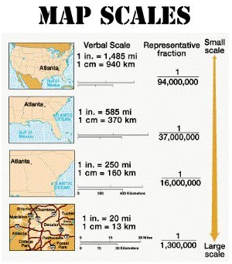
LARGE SCALE MAPS:

Scale of Analysis

What is meant by Scale of Analysis?
- ________________________________________________________________________
______________________________. It is important for you to identify the scale of analysis in four different ways: ______________, ______________, ______________ OR ______________.

GLOBAL SCALE OF ANALYSIS REGIONAL SCALE OF ANALYSIS
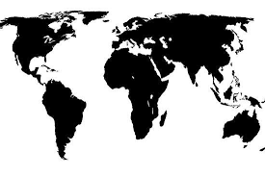  *Notice how there are no boundary lines depicted in the map  **The map scale of the map is the smallest scale (think zoom out) | 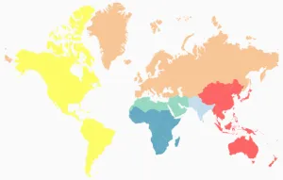  *Notice how there are regional boundary lines, but not national political boundaries.  **The map scale of the map is still small scale (zoomed out)
- This level of analysis is usually not that useful and is almost impossible to use. | - Consider major world regions, like Southeast Asia, Sub-Saharan Africa, Oceania, Anglo-America, etc.

NATIONAL SCALE OF ANALYSIS LOCAL SCALE OF ANALYSIS
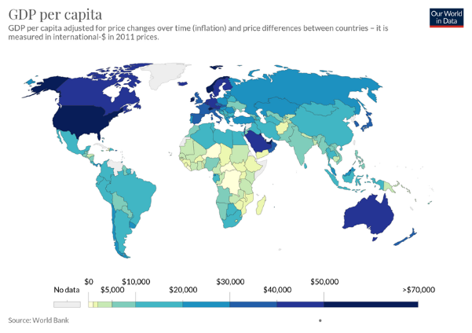  *Notice how there ARE political boundary lines depicted in the map with different levels of data based on GDP per capita  **The map scale of the map is large scale (think zoom out) | 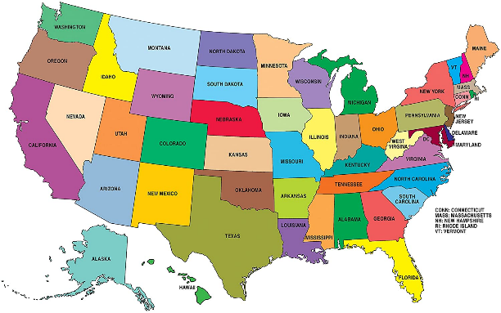  *Notice how there are subregional boundary lines within the United States depicted in the map above  **The map scale of the map is the small scale (zoomed in)
- Example: Using the map above, we can determine that the United States has an extremely high GDP per capita, but that the Democratic Republic of the Congo (DRC) has an extremely low GDP per capita. | - Example: the states within the United States (you could also show more localized, like counties, zip codes)

- Complete the practice questions on the next page based on Scale of Analysis
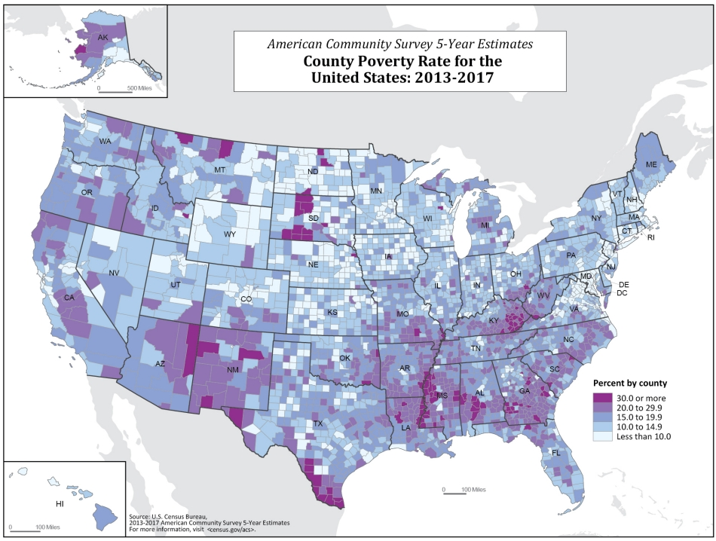 | 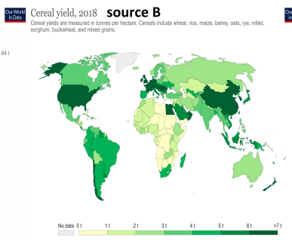
What is the map scale AND scale of analysis of the data?  How do you know? | What is the map scale AND scale of analysis of the data?  How do you know?
Risk of Conflict  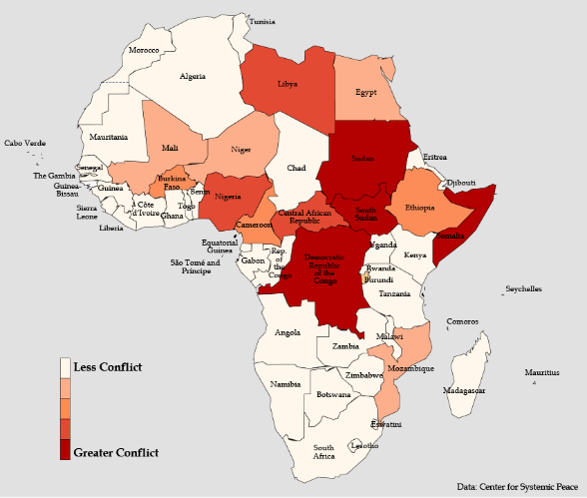 | 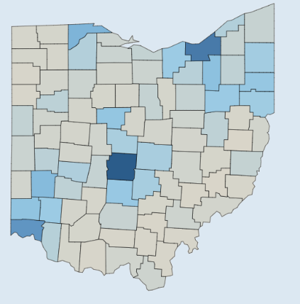
What is the map scale AND scale of analysis of the data?  How do you know? | What is the map scale AND scale of analysis of the data?  How do you know?

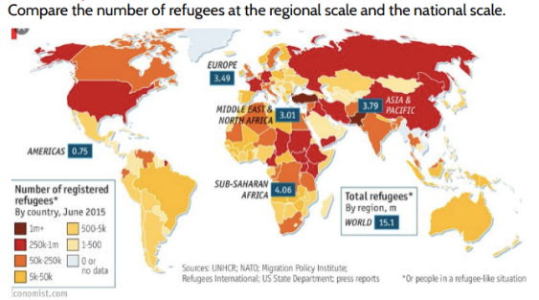 | 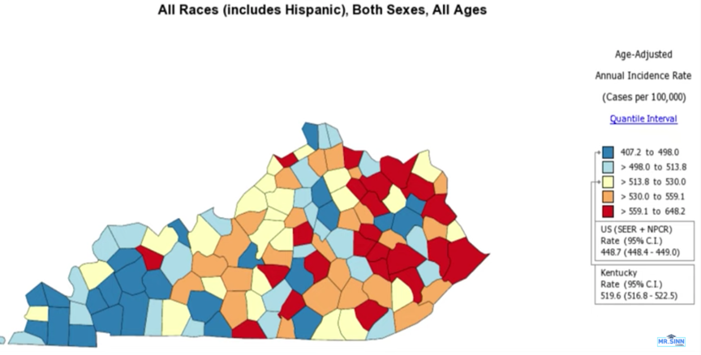
What is the map scale AND scale of analysis of the data?  How do you know? | What is the map scale AND scale of analysis of the data?  How do you know?

