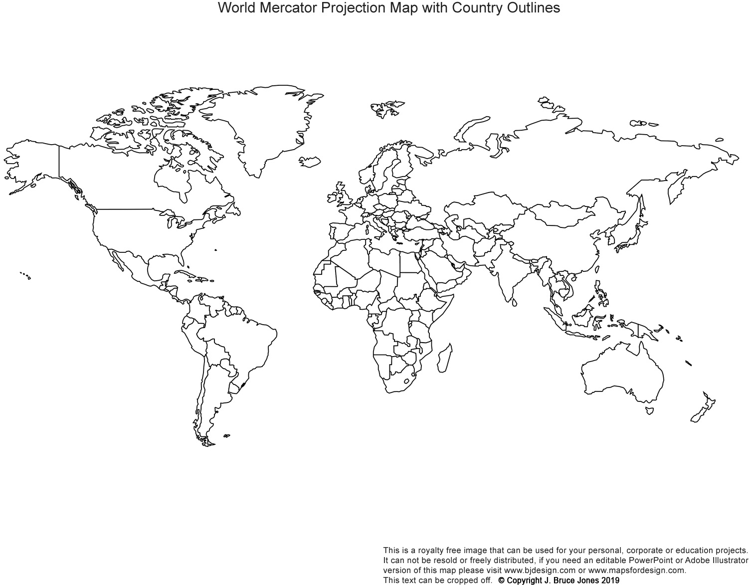
Name: Period#
Universalizing Religions – pages 176 – 177 in De Blij (green textbook) | Ethnic Religions
- Christianity  - Roman Catholic (YELLOW)  - Protestant (LIGHT GREEN)  - Eastern Orthodox (GREEN)  - Islam  - Sunni (LIGHT BLUE)  - Shia (BLUE)  - Buddhism (RED) | - Hinduism (BROWN)  - Judaism (write letter ‘J’ for locations)  - Mormonism (write letter ‘M’ for locations)

