Name: ____________________________________ Period# ______ Topic 2.3 Population Composition

Population Pyramid Lecture:

- Depicts _____________________________________________
- Uses age categories (in groups of 5)
- Divided by gender
  - _________ on left side
  - ____________ on right side

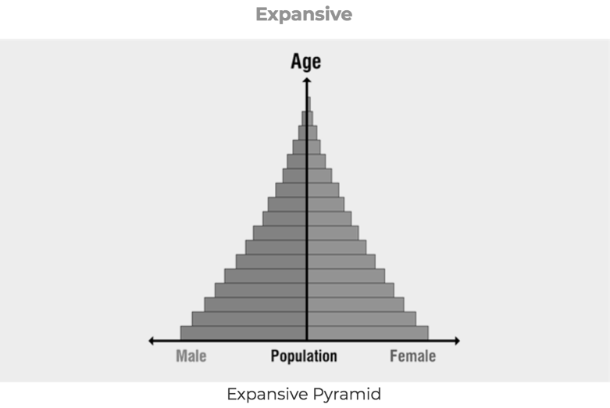
Expansive Pyramid (aka Christmas tree)

_______________________________________________
_______________________________________________
_______________________________________________
_______________________________________________
_______________________________________________
_______________________________________________
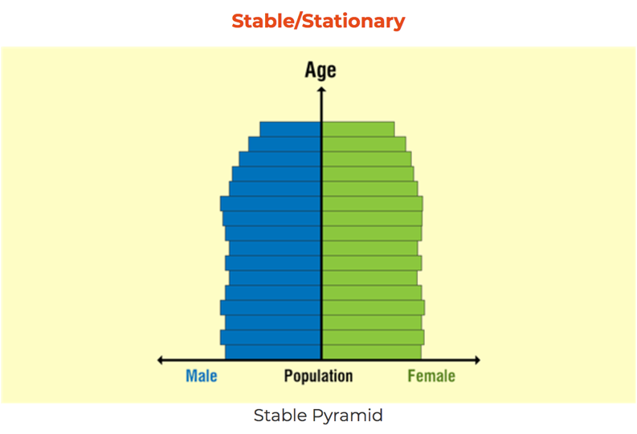
Stable/Stationary Pyramid (aka beehive)

_______________________________________________
_______________________________________________
_______________________________________________
_______________________________________________
_______________________________________________
_______________________________________________

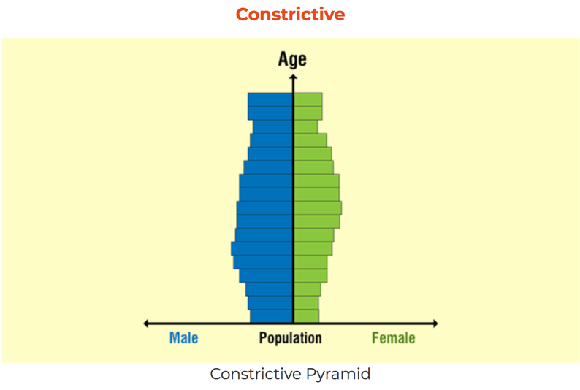
Constrictive Pyramid (aka cup)

_______________________________________________
_______________________________________________
_______________________________________________
_______________________________________________
_______________________________________________
_______________________________________________

Dependency Ratio | Impacts of Dependency Ratio
- under the age of 15 and over the age of 65  - What is the demand being placed on the  working age population to provide for the  dependent population?  - Youth dependency  - Elderly dependency | - High dependency ratio =  - ____________________________________  - ____________________________________  - Not paying taxes  - Dependent on state healthcare?  - Schools?  - Living facilities?  - Hospitals?  - Working population face =  - ____________________________________

Sex Ratio
Sex Ratio: _______________________________________________________________________
- Important to examine at multiple scales!
- What would cause fewer women or fewer men in a society?
  - _______________
  - Insufficient healthcare for women
  - _____________________________
  - Gendercide/Sex-Selective Abortions

_________________________________________________________________________________________________

Population Pyramid Video: https://www.youtube.com/watch?v=RLmKfXwWQtE

Video Questions:

- Why might a certain age group have more females than males?

- What factors might account for differences in Population Pyramids between cities within the same country?

- What services would a fast growth country in comparison to a slow growth country need to consider increasing for the benefit of its people?

