Longitude and Latitude

Name: ______________________________________ Period# _____

- Draw a line along the equator and label it.

- Draw a line along the Prime Meridian and label it.

- In which ocean is the location 10 degrees S latitude, 75 degrees E longitude located? Mark it on the map with a "X" and write the name of the ocean.

- In which ocean is the location 30 degrees N latitude, 60 degrees W longitude located? Mark it on the map with a "Y" and write the name of the ocean.

5. Mark the following cities on the map with a dot and write the abbreviation next to it: (MAP ON BACK)
B. Beijing: 40°N, 116°E
C. Cairo: 30°N, 31°E
CT. Cape Town: 34°S, 18°E
H. Hong Kong: 22°N, 114°E
J. Jakarta: 6°S, 106°E
LA. Los Angeles: 34°N, 118°W
LI. Lima: 12°S, 77°W
LO. London: 51°N, 0°W
MC. Mexico City: 19°N, 99°W
MO. Moscow: 55°N, 37°E
MU. Mumbai: 19°N, 72°E
NA. Nairobi: 1°S, 37°E
NO. New Orleans: 30°N, 90°W
NY. New York: 40°N, 74°W
R, Rio de Janeiro: 23°S, 43°W
SE. Seattle: 47°N, 122°W
SY. Sydney: 34°S, 151°E
TK. Tokyo: 35°N, 139°E
T. Toronto: 43°N, 79°W

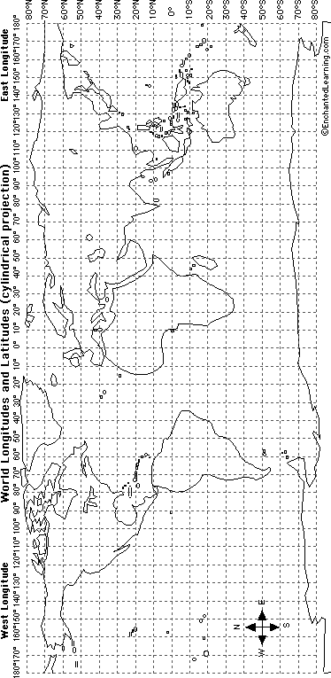

Name: _____________________________________ Period# ____

Time Zones? What’s the point?

Video Link: https://youtu.be/-j-SWKtWEcU

Rise at 11? China’s Single Time Zone Means Keeping Odd Hours (Modified) Javier C. Hernandez / June 16, 2016 Some days, the sun doesn’t come up until 10 a.m. or later. People eat lunch after 2 p.m., or even after 4 if they’re not in a rush. The school day stretches so late that children can’t get home in time to catch their favorite cartoon shows. Why are the clocks in Urumqi, China, so far out of kilter with the cycles of the sun? Because of the legacy of Mao Zedong, a Chinese leader in the 1940s, and the Communist Party’s desire for unified control. Though China is almost as wide as the continental United States, the whole country is officially in just one-time zone — Beijing time. So when it’s 7 a.m. in the Forbidden City, it’s also officially 7 a.m. 2,000 miles to the west in Urumqi, the capital of the Xinjiang region — even if the stars are still out there. That can lead to headaches — and lost sleep. “It’s hard to adjust,” says Gao Li, a sanitation worker in Urumqi. “I often think we must be the only people who eat dinner at midnight.” So schools, airports and train stations operate at odd hours; national exams are sometimes given in the dead of night; and restaurants stay open for dinner into the wee hours. The eccentricities of the clock also tend to divide people in Xinjiang by ethnicity. The Uighurs, Turkic-speaking Muslims who consider the region their homeland, tend to set their clocks two hours earlier, to more closely match the local day. But the Han Chinese who live there, members of China’s predominant ethnic group, generally follow Beijing time. The discrepancies can be a source of confusion and frustration, especially for younger people who frequently socialize across ethnic lines.

1. What effect does it have on the people of Western China to have only one time zone?

2. Why does China have only one time-zone?

3. Who are the Uighurs? And who are the Han Chinese?

4. How has the time zone caused divisions between the Uighurs and the Han Chinese?

