Name: __________________________________ Period# ____ Topic 7.2 – Weber’s Least Cost

3 MAJOR FACTORS THAT DETERMINE LOCATION
• 1. Transportation (most important)
• _____________________________________________
• Finished goods (outputs) to market
• _____________ and ____________ most important factors.
• 2. Labor
• High _______________________________________________
• May locate farther from inputs/ market if cheap labor can make up for added transport costs.
• 3. Agglomeration
• Similar ______________________________________________
• Businesses __________________________, reduce costs

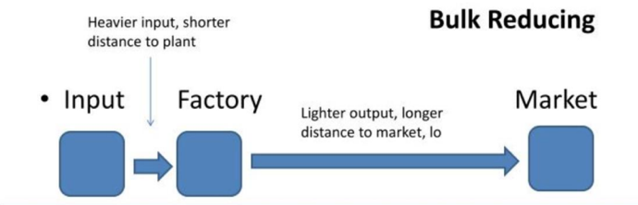
BULK REDUCING INDUSTRY
• Inputs ___________________________________________.
• Weight is lost during the production process
• __________________________________________________
> cost of shipping outputs to market.
• Therefore, factory is located near raw materials/ inputs.
• Examples: copper, steel, lumber

BULK GAINING INDUSTRY
• Finished product weighs more than the inputs.
• Weight ___________________________________________________________________.
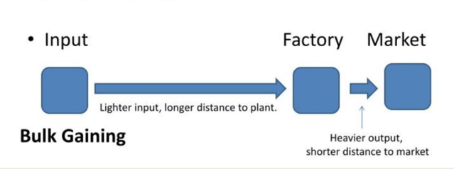
• _______________________________________________ > cost of shipping inputs to factory.
• Therefore, factory is located near the market.
• Examples: _______________, ________________

LCOATIONAL TRIANGLE EXAMPLE
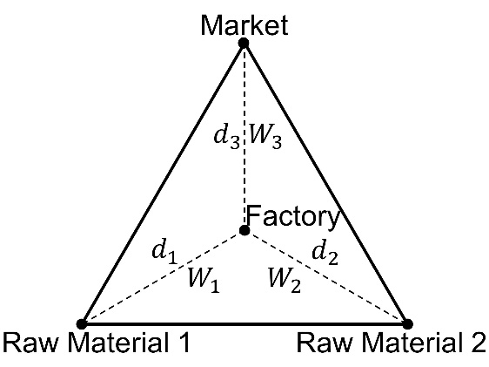
Ex.

Video Questions:

1.Complete the chart
 | Description | Economic Sector(s) | Examples of Countries
Core
Semi-Periphery
Periphery

2.What are bulk-points?

