Name: _______________________________________ Period# ____
A = Identify & Define
A & E = Describe & Compare/Contrast
ACE = Explain
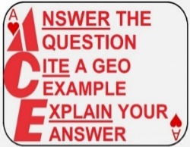
FRQ Practice:
FRQ Task Verbs:
- Compare: Provide a description or explanation of similarities and/or differences.
- Define: Provide a specific meaning for a word or concept.
- Describe: Provide the relevant characteristics of a specified topic.
- Explain: Provide information about how or why a relationship, process, pattern, position, or outcome
occurs, using evidence and/or reasoning.
- Identify: Indicate or provide information about a specified topic, without elaboration or explanation.

ACE the FRQs:

- When identifying, answer the question.
- When describing, answer the question AND explain your answer.
- When explaining, answer the question, cite a geographic example, explain your answer AND example.
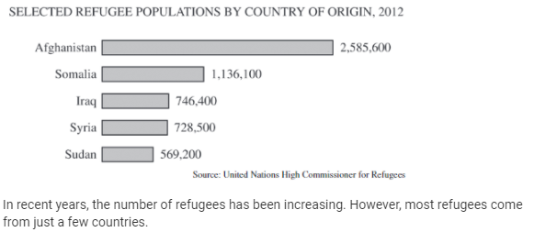
How would you grade the following FRQ?
- Define the term “refugee”
a. A person who flees, is displaced,
or is forced to leave his or her home
country.

- Describe ONE positive effects for countries
that receive migrants.
b. Migrants provide cheap labor in the developed countries. This benefits a country because these migrants are doing types of labor such as agricultures, construction, hospitality services that are not desires by the native population.

- Describe ONE positive effects for countries that send migrants.
  - Migrants often send remittances (money) back to family and friends in the sending country. This is beneficial because it allows family/friends better opportunities that can improve their lifestyle/standard of living.

- Using the chart shown, select a country of origin and explain ONE reason why refugees have left the country
  - Afghanistan has been recently affected by political push factors. For example, in August of 2021 Afghanistan’s government crumbled as the Taliban took over the entire country. Under the new regime, the Taliban, people are in fear of their lives that the Taliban will persecute them for not following Islamic law. In response to this event, hundreds of thousands of Afghan nationals have left the country and are now seeking asylum in countries like the United States, England, and Canada.

Unit 2 FRQ is MONDAY!
FRQ will contain some/all of the following topics:
- Topics 2.4, 2.5, 2.7, 2.8
(I highly suggest looking over these topics this weekend – this will be the FINAL grade in the gradebook)

Your turn . . .
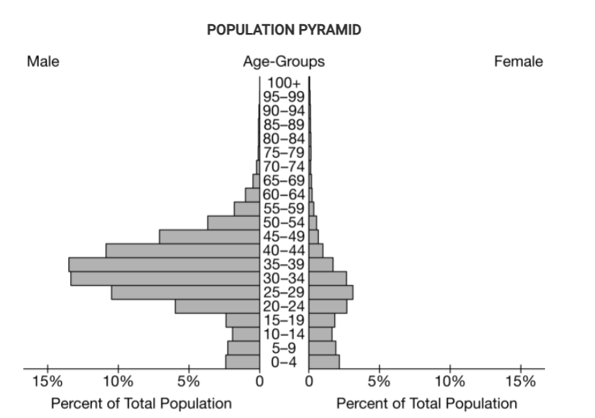
- Explain why the population shown in the pyramid might have this particular sex ratio.

- Describe a cultural/social push factor that would motivate a male migrant from a rural area to move to an urban area in a very distant location.

- Describe a political push factor that would motivate a male migrant from a rural area to move to an urban area in a very distant location.

- Identify a country that has a lot of “pull factors” and identify a country that has a lot of “push factors”

A.

B.

C.

D.

