Speed Dating: DTM
Name: _________________________________ Period: _______
Welcome to Speed Dating: DTM! Today you will have the opportunity find the love of your life; a country in a similar stage of life as you. You will have 1.5 minutes to get to know several other countries. You will have 1.5 minutes to share a bit about your country. Jot down some notes as the other country introduces him/herself to help you determine what stage they are in & if they are a good match for you. Remember, do NOT use names for now just use letters or numbers to identify yourself. Keep a bit of mystery. Good Luck! Be yourself!
To be more successful in picking your DTM soul mate, you must know yourself well. Take a minute to think about what you (as a country) are looking for in a partner.
Your country: _________________________
- How many kids do you want? (CBR- Crude Birth Rate & TFR – Total Fertility Rate)

- Where do you see yourself in the future? (CDR – Crude Death Rate, Life Expectancy & Natural Increase Rate)

- Where is your ideal place to live? (Percent Urban or Rural)

- How developed is your country? (Literacy Rate/Technology)

- What kind of jobs do you have/how much money do you make? (GDP/what type of economy)

- Talk about your family. (Percent of population >15 & 64+)

- Draw the population pyramid for your country
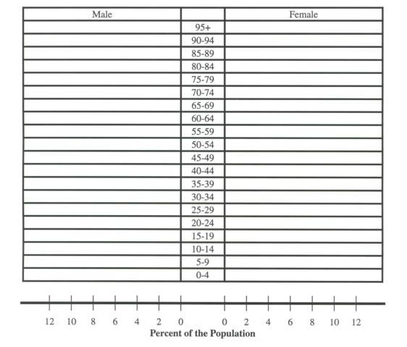

Country | Characteristics (similarities/differences to your country) | Good fit? Why/Not? | DTM Stage Prediction

Name: ___________________________________ Period# _____
DTM Speed Dating Wrap-up Questions:
- Which country(ies) seem to be the best fit for you?

- What do you have in common?

- What challenges might there be to your relationship?

- What country(ies) seem to be the worst fit? Why?

Name: ___________________________________ Period# _____
DTM Speed Dating Wrap-up Questions:
- Which country(ies) seem to be the best fit for you?

- What do you have in common?

- What challenges might there be to your relationship?

- What country(ies) seem to be the worst fit? Why?

