Name: _________________________________________ Period# _____ TOPIC 1.2 Geographic Data
Part 1:
Address: | Sex and Age | Address: | Sex and Age
A1 Knight Ave | 14 M, 8F, 34F, 36M | D1 Florence St | None
A2 Knight Ave |  | D2 Florence St
A3 Knight Ave |  | D3 Florence St
A4 Knight Ave |  | D4 Florence St
A5 Knight Ave |  | E1 West Ave
A6 Knight Ave |  | E2 West Ave
B1 Knight Ave |  | E3 West Ave
B2 Knight Ave |  | E4 West Ave
B3 Knight Ave |  | E5 West Ave
B4 Knight Ave |  | F1 West Ave
B5 Knight Ave |  | F2 West Ave
C1 Florence St |  | F3 West Ave
C2 Florence S |  | F4 West Ave
C3 Florence S |  | F5 West Ave
C4 Florence St |  | F6 West Ave
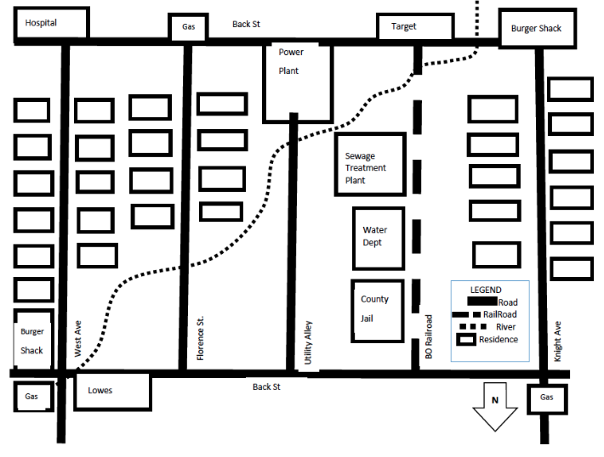

A1
C1
F1
E1
D1
B1

Look over the data on the paper and on the map.
- Where do you think the source of cholera contamination is located?

- Where do you predict future spread will occur?

- How do you propose to eradicate the spread of cholera in this neighborhood?

Part 2:
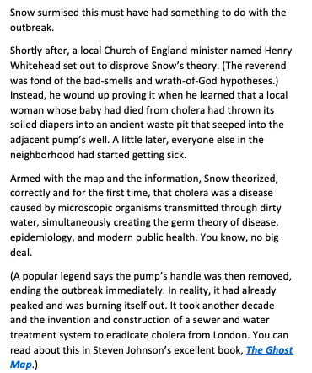
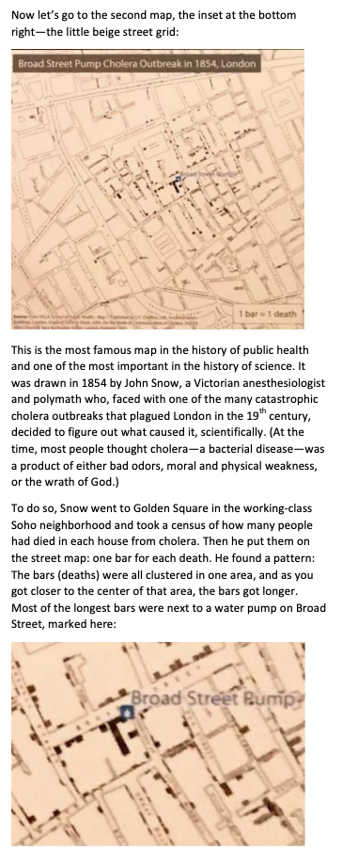
- Who drew the most famous map in the history of public health?

- At the time (1854), what did most people think caused cholera?

- Snow’s map illustrated that most of the cholera deaths were clustered around?

- What correct theory did Snow’s map lead to?
Part 3:
Watch the following on John Snow’s mapping of the cholera outbreak
https://www.vox.com/2020/6/12/21289030/john-snow-map-cholera

