Free Response Question (FRQ) Outline
Part 2 of the AP Human Geography exam (Thursday, May 5th, 2022 @8 AM) is worth 50% of your exam score and consists of writing three FRQ essays in 75 minutes. All three questions will assess at least two different units of instruction, present an authentic geographic situation or scenario, and at least two will ask you to explain and analyze spatial relationships across geographic scales.

- Each FRQ question is worth 7 points.
- The first question will have text only.
- The second question will ask you to analyze and/or interpret data, an image, or a map.
- The third question will feature two stimuli, which will include data, images, and/or maps

FRQ Task Verbs:
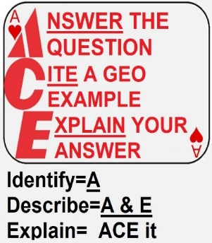
- Compare: Provide a description or explanation of similarities and/or differences.
- Define: Provide a specific meaning for a word or concept.
- Describe: Provide the relevant characteristics of a specified topic.
- Explain: Provide information about how or why a relationship, process, pattern, position, or outcome occurs, using evidence and/or reasoning.
- Identify: Indicate or provide information about a specified topic, without elaboration or explanation.

ACE the FRQs:

- When identifying, answer the question.
- When describing, answer the question AND explain your answer.
- When explaining, answer the question, cite a geographic example, explain your answer AND example.
Write the FRQ Prompt below AND identify which part of the question you’re answering

In the section above, underline the FRQ task verb.
According to the task verb, which components of ACE must your answer include? Circle all that apply: A C E
ANSWER the question
CITE a geographic example
- make sure it supports the question
- You don’t always have to create your own geographic example. If the question gives you one, use it.
EXPLAIN your answer

Pizza– FRQ

- Define Pizza.

- Describe Pizza.

- Compare (and Contrast) the types of Pizza.

- Identify types of Pizza.

- Explain how Pizza is made.

