Name: _________________________________________ Period# _____ **PRACTICE QUIZ:** https://tinyurl.com/25nh95k7

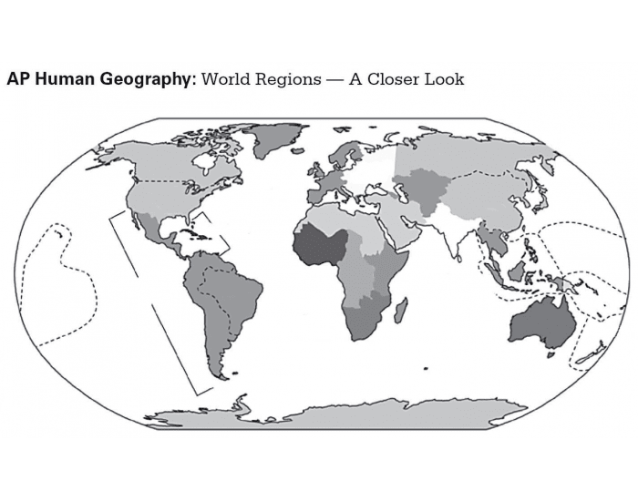

**Use page 26 to label**

**1**

**22**

**21**

**20**

**18**

**19**

**16**

**17**

**15**

**14**

**13**

**12**

**11****11**

**10**

**9**

**8**

**7**

**6**

**5**

**4**

**3**

**2**

**1**

1. ____________________________ 9) ___________________________ 17) ____________________________
2. ____________________________ 10 ___________________________ 18) ____________________________
3. ____________________________ 11) ___________________________ 19) ____________________________
4. ____________________________ 12) ___________________________ 20) ____________________________
5. ____________________________ 13) ___________________________ 21) ____________________________
6. ____________________________ 14) ___________________________ 22) ____________________________
7. ____________________________ 15) ___________________________
8. ____________________________ 16) ___________________________