Name: ________________________________ Period# ____ Topic 2.2 – Consequences of Population Distribution
2.2 Explain how population distribution and density affect society and the environment.
- Population distribution and density affect political, economic, and social processes, including the provision of services such as medical care.
- Population distribution and density affect the environment and natural resources; this is known as carrying capacity.

How does population distribution and density affect society and the environment?
ESPN (Economic, Social, Political, and Natural/Environment
Economic | - Competition for jobs.  - Urbanization due to manufacturing and industrialization.  - Today, ____________________________________________________________  - Uneven ________________________________________________________________.  - Scattered/dispersed populations  - ___________________ -> less access to services-> Overall, less developed
Social | - Social Services & Infrastructure: ______________________________________________ to housing, jobs, water, and services like sanitation, medical care, fire, police, public transportation and waste collection.  - Actually ________________________________________________________  ________________________________- less distance & travel. Rural areas have a dispersed population, but fewer facilities.  - Yet, it is still extensive to provide services for large amounts of people.
Political | - Representation in Government  - Electoral Districts which have to be roughly __________________________  ____________________.  - Determines _____________________________________________________  - Redistricting -> process of redrawing electoral district boundaries after the Census every 10 years.
Natural/  Environment | - Carrying Capacity: _________________________________________________________.  - High population density = pressures on the _________________, __________, _______________, and ______________ supply.  - _________ and _____________ pollution, _________________________, use of large amounts of energy, excessive waste

Topic 2.6 – Malthusian Theory
Population, Sustainability, and Malthus
Video Link: https://youtu.be/QAkW_i0bDpQ
- In 10,000 BCE, fewer than a ________________________ people lived on earth. Around 1800 CE, human population had grown to _________________________________.

- What forces did Thomas Malthus theorize would check the population of humans?
  - How have humans traditionally dealt with some of these forces?

  - For Malthus, uncontrolled ________________________ was the central problem.

  - What did Malthus call his theory of history?
  - How did Malthusian theory play a role in the Irish Potato Famine of 1846-1851?
- From 1750 to 1850, the number of humans on Earth grew from about 800 million to ______________________. By 1960, the population reached ____________________. And since then, the world has added a billion humans roughly every ____ years. Sometime in 2009 or 2010, the United Nations estimates that the Earth’s ____________ person was born.

- What two major revolutions in food production were occurring during Malthus’ lifetime?
- The most important innovation of Europe’s agricultural revolution was largely invisible—it was the decision to treat land as ___________________________________.
  - Only through historical hindsight do we know that private property _____________________
__________________________________________________________________ to experiment with new methods of food production, which dramatically increased the amount of food produced.

- Why was Malthus wrong about his theory/prediction?
Topic 2.6 – Malthusian Theory
2.6 Explain theories of population growth & decline.
- Malthusian theory and its critiques are used to analyze population change and its consequences.

Malthusian Theory
Malthus’ Claim:
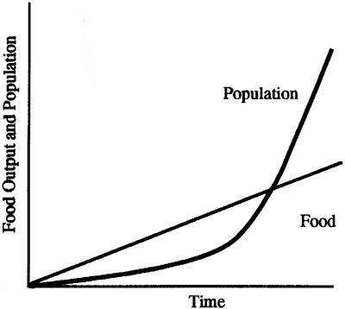
- Population grows exponentially while food output only grow arithmetically. This would result in a food shortage and famine due to overpopulation.
  - Exponentially: 2, 4, 8, 16
POINT OF CRISIS
  - Arithmetically: 1, 2, 3, 4

Criticisms of Malthusian Theory
- Factors that have slowed population growth:
  - _______________________________
  - _____________________________________________of women
- Factors that have increased the efficiency of farming:
  - ___________________________
  - Hybrid Seeds
  - ______________________________
- New Technologies and Inventions:
  - More efficient travel to deliver food to a wider range of consumers without spoiling.
  - _______________________________________ as well as homes to preserve food.
  - ___________________________________ for longer time periods.

Neo-Malthusians
Neo = new
- Concerns about ______________________________________________________ - the earth’s resources cannot only sustain a finite (limited) population.
  - Decreasing birth rates in developed countries
  - ________________________________________
    - ___________________________, Desertification, pollution of air and water, etc.
  - Overconsumption
  - Famine & Starvation

